|  |
| --- |
| Swayam |
| **Introduction to Abstract and Linear Algebra** |
| Prof. Sourav Mukhopadhyay | IIT Kharagpur |

|  |
| --- |
| VARUN KUMAR  9-20-2025 |

Table of Contents

[**Week 1: Basic Set Theory** 2](#_Toc200478721)

[Lecture 01: - Set Theory 2](#_Toc200478722)

[**Week – 02: Group Theory** 3](#_Toc200478723)

[**Week – 03: Rings and Polynomial Rings** 4](#_Toc200478724)

[**Week – 04: Field and Finite Field** 5](#_Toc200478725)

[**Week – 05: Matrices and Determinants** 6](#_Toc200478726)

[**Week – 06: Vector Spaces over Field** 7](#_Toc200478727)

[**Week – 07: Linear Transformation and Their Matrices** 8](#_Toc200478728)

[Lecture 31: - Rank of a Matrix 8](#_Toc200478729)

[Lecture 32: - Rank of a Matrix (contd….) 10](#_Toc200478730)

[Lecture 33: - System of Linear Equations 16](#_Toc200478731)

[Lecture 34: - Row Rank and Column Rank 19](#_Toc200478732)

[Lecture 35: - Eigen Value of a Matrix 22](#_Toc200478733)

[**Test Questions** 26](#_Toc200478734)

[2019 26](#_Toc200478735)

[2023 29](#_Toc200478736)

[2024 32](#_Toc200478737)

[**Week – 08: Linear Equations** 36](#_Toc200478738)

[Lecture 36: - Eigen Vector 36](#_Toc200478739)

[**Test Papers of 2025** 38](#_Toc200478740)

[Week – 01: 38](#_Toc200478741)

[Week – 07: 38](#_Toc200478742)

[**Important Links** 39](#_Toc200478743)

# **Week 1: Basic Set Theory**

## Lecture 01: - Set Theory

**Topics to be Covered: -**

* Definition of Set,
* Representation of set,
* Empty set,
* universal Set,
* Subset.

# **Week – 02: Group Theory**

# **Week – 03: Rings and Polynomial Rings**

# **Week – 04: Field and Finite Field**

# **Week – 05: Matrices and Determinants**

# **Week – 06: Vector Spaces over Field**

# **Week – 07: Linear Transformation and Their Matrices**

## Lecture 31: - Rank of a Matrix

**Topics to be Covered**: -

* Definition of Rank of a Matrix,
* Maximum Order of Non-Zero Minor, Elementary Row and Column Operations,
* Row reduced Echelon Form, Row Equivalence

Matrix is a rectangular arrangement of elements

Ink Drawings
Ink Drawings
Ink Drawings
Ink Drawings
Ink Drawings
Ink Drawings
Ink Drawings
Ink Drawings
Ink Drawings
Ink Drawings
Ink Drawings
Ink Drawings
Ink Drawings
Ink Drawings
Ink Drawings
Ink Drawings
Ink Drawings
Ink Drawings
Ink Drawings
Ink Drawings
Ink Drawings
Ink Drawings
Ink Drawings
Ink Drawings
Ink Drawings
Ink Drawings
Ink Drawings
Ink Drawings
Ink Drawings
Ink Drawings
Ink Drawings
Ink Drawings
Ink Drawings
Ink Drawings
Ink Drawings
Ink Drawings
Ink Drawings
Ink Drawings
Ink Drawings
Ink Drawings
Ink Drawings
Ink Drawings
Ink Drawings
Ink Drawings
Ink Drawings
Ink Drawings
Ink Drawings
Ink Drawings
Ink Drawings
Ink Drawings
Ink Drawings
Ink Drawings
Ink Drawings
Ink Drawings
Ink Drawings
Ink Drawings
Ink Drawings
Ink Drawings
Ink Drawings
Ink Drawings
Ink Drawings
Ink Drawings
Ink Drawings
Ink Drawings
Ink Drawings


Ink Drawings
Ink Drawings
Ink Drawings
Ink Drawings
Ink Drawings
Ink Drawings
Ink Drawings
Ink Drawings
Ink Drawings
Ink Drawings
Ink Drawings
Ink Drawings
Ink Drawings
Ink Drawings
Ink Drawings
Ink Drawings
Ink Drawings
Ink Drawings
Ink Drawings
Ink Drawings
Ink Drawings
Ink Drawings
Ink Drawings
Ink Drawings
Ink Drawings
Ink Drawings
Ink Drawings
Ink Drawings
Ink Drawings
Ink Drawings
Ink Drawings
Ink Drawings
Ink Drawings
Ink Drawings
Ink Drawings
Ink Drawings
Ink Drawings
Ink Drawings
Ink Drawings
Ink Drawings
Ink Drawings
Ink Drawings
Ink Drawings
Ink Drawings
Ink Drawings
Ink Drawings
Ink Drawings
Ink Drawings
Ink Drawings
Ink Drawings
Ink Drawings
Ink Drawings
Ink Drawings
Ink Drawings
Ink Drawings
Ink Drawings
Ink Drawings
Ink Drawings


Ink Drawings
Ink Drawings
Ink Drawings
Ink Drawings
𝐴=﷐﷐2﷮3﷮−1﷮1﷮3﷮0﷮4﷮2﷮6﷮9﷮−3﷮3﷯﷯ 
Ink Drawings
Ink Drawings
Ink Drawings
Ink Drawings
Ink Drawings


Ink Drawings
Ink Drawings
Ink Drawings
Ink Drawings
Ink Drawings
Ink Drawings
Ink Drawings
Ink Drawings
Ink Drawings
Ink Drawings
Ink Drawings
Ink Drawings
Ink Drawings
Ink Drawings
Ink Drawings
Ink Drawings
Ink Drawings
Ink Drawings
Ink Drawings
Ink Drawings
Ink Drawings
Ink Drawings
Ink Drawings
Ink Drawings
Ink Drawings
Ink Drawings
Ink Drawings
Ink Drawings
Ink Drawings
Rank of 0 Matrix is 0
Rank of 0 Matrix is 0
Ink Drawings
Ink Drawings
﷐﷐2﷮3﷮−1﷮3﷮0﷮4﷮6﷮9﷮−3﷯﷯=2﷐0 −36﷯ −3﷐−9 −24﷯−1﷐27 −0﷯

  =−72+99 −27=0
﷐﷐3﷮−1﷮1﷮0﷮4﷮2﷮9﷮−3﷮3﷯﷯=0
Ink Drawings
Ink Drawings
Ink Drawings
Ink Drawings
Ink Drawings
Ink Drawings
Ink Drawings
Ink Drawings
Ink Drawings
Ink Drawings
Ink Drawings
Ink Drawings
Ink Drawings
Ink Drawings
Ink Drawings
Ink Drawings
Ink Drawings
Ink Drawings
Ink Drawings
Ink Drawings
Ink Drawings
Ink Drawings
Ink Drawings
Ink Drawings
Ink Drawings
Ink Drawings
Ink Drawings
Ink Drawings
Ink Drawings
Ink Drawings
Ink Drawings
Ink Drawings
Ink Drawings
﷐﷐2﷮3﷮3﷮0﷯﷯=−9 ≠0
Ink Drawings
Ink Drawings
Ink Drawings
Ink Drawings
Ink Drawings
Ink Drawings
Ink Drawings
Ink Drawings
Ink Drawings
Ink Drawings
Ink Drawings


Ink Drawings
Ink Drawings
Ink Drawings
Ink Drawings
Ink Drawings
Ink Drawings
Ink Drawings
Ink Drawings
Ink Drawings
Ink Drawings
Ink Drawings
Ink Drawings
Ink Drawings
Ink Drawings
Ink Drawings
Ink Drawings
Ink Drawings
Ink Drawings
Ink Drawings
Ink Drawings
Ink Drawings
Ink Drawings
Ink Drawings
Ink Drawings
Ink Drawings
Ink Drawings
Ink Drawings
Ink Drawings
Ink Drawings
Ink Drawings
Ink Drawings
Ink Drawings
Ink Drawings
Ink Drawings
Ink Drawings
Ink Drawings
Ink Drawings
Ink Drawings
Ink Drawings
Ink Drawings
Ink Drawings


Ink Drawings
Ink Drawings
Ink Drawings
Ink Drawings
Ink Drawings
Ink Drawings
Ink Drawings
Ink Drawings
Ink Drawings
Ink Drawings
Ink Drawings
Ink Drawings
Ink Drawings
Ink Drawings
Ink Drawings
Ink Drawings
Ink Drawings
Ink Drawings
Ink Drawings
Ink Drawings
Ink Drawings
Ink Drawings
Ink Drawings
Ink Drawings
Ink Drawings
Ink Drawings
Ink Drawings
Ink Drawings
Ink Drawings
Ink Drawings
Ink Drawings
Ink Drawings
Ink Drawings
Ink Drawings
Ink Drawings
Ink Drawings
Ink Drawings
Ink Drawings
Ink Drawings
Ink Drawings
Ink Drawings
Ink Drawings
Ink Drawings
Ink Drawings
Ink Drawings
Ink Drawings
Ink Drawings
Ink Drawings
Ink Drawings
Ink Drawings
Ink Drawings
Ink Drawings
Ink Drawings
Ink Drawings
Ink Drawings
Ink Drawings
Ink Drawings
Ink Drawings
Ink Drawings
Ink Drawings
Ink Drawings
Ink Drawings
Ink Drawings
Ink Drawings
Ink Drawings
Ink Drawings
Ink Drawings
Ink Drawings
Ink Drawings
Ink Drawings
Ink Drawings
Ink Drawings
Ink Drawings
Ink Drawings
Ink Drawings
Ink Drawings
Ink Drawings
Ink Drawings
Ink Drawings
Ink Drawings
Ink Drawings
Ink Drawings
Ink Drawings
Ink Drawings
Ink Drawings
Ink Drawings
Ink Drawings
Ink Drawings
Ink Drawings
Ink Drawings
Ink Drawings
Ink Drawings
Ink Drawings
Ink Drawings
Ink Drawings
Ink Drawings
Ink Drawings
Ink Drawings
Ink Drawings
Ink Drawings
Ink Drawings
Ink Drawings
Ink Drawings
Ink Drawings
Ink Drawings
Ink Drawings
Ink Drawings
Ink Drawings
Ink Drawings
Ink Drawings
Ink Drawings
Ink Drawings
Ink Drawings
Ink Drawings
Ink Drawings
Ink Drawings
Ink Drawings
Ink Drawings
Ink Drawings
Ink Drawings
Ink Drawings
Ink Drawings
Ink Drawings
Ink Drawings
Ink Drawings
Ink Drawings
Ink Drawings
Ink Drawings
Ink Drawings
Ink Drawings
Ink Drawings
Ink Drawings
Ink Drawings
Ink Drawings
Ink Drawings
Ink Drawings
Ink Drawings
Ink Drawings
Ink Drawings
Ink Drawings
Ink Drawings
Ink Drawings
Ink Drawings
Ink Drawings
Ink Drawings
Ink Drawings
Ink Drawings
Ink Drawings
Ink Drawings
Ink Drawings
Ink Drawings
Ink Drawings
Ink Drawings
Ink Drawings
Ink Drawings
Ink Drawings
Ink Drawings
Ink Drawings
Ink Drawings
Ink Drawings
Ink Drawings
Ink Drawings


𝐴=﷐﷐1﷮0﷮1﷮3﷮4﷮5﷮2﷮3﷮4﷯﷯
Ink Drawings
Ink Drawings
Ink Drawings
Ink Drawings
Ink Drawings
Ink Drawings
Ink Drawings
Ink Drawings
Ink Drawings
Ink Drawings
Ink Drawings
Ink Drawings
Ink Drawings
Ink Drawings
Ink Drawings
Ink Drawings
Ink Drawings
Ink Drawings
Ink Drawings
Ink Drawings
Ink Drawings
Ink Drawings
Ink Drawings
Ink Drawings
Ink Drawings
Ink Drawings
Ink Drawings
Ink Drawings
Ink Drawings
Ink Drawings
Ink Drawings
Ink Drawings
Ink Drawings
Ink Drawings
Ink Drawings
Ink Drawings
Ink Drawings
Ink Drawings
Ink Drawings
Ink Drawings
Ink Drawings
Ink Drawings
Ink Drawings
Ink Drawings
Ink Drawings
Ink Drawings
Ink Drawings
Ink Drawings
Ink Drawings
Ink Drawings
Ink Drawings
Ink Drawings
Ink Drawings
Ink Drawings
Ink Drawings
Ink Drawings
Ink Drawings
Ink Drawings
Ink Drawings
Ink Drawings
Ink Drawings
Ink Drawings
Ink Drawings
Ink Drawings
Ink Drawings
Ink Drawings
Ink Drawings
Ink Drawings
Ink Drawings
Ink Drawings
Ink Drawings
Ink Drawings
Ink Drawings
Ink Drawings
Ink Drawings
Ink Drawings
Ink Drawings
Ink Drawings
Ink Drawings
Ink Drawings
Ink Drawings
Ink Drawings
Ink Drawings
Ink Drawings
Ink Drawings
Ink Drawings
Ink Drawings
Ink Drawings
Ink Drawings
Ink Drawings
Ink Drawings
Ink Drawings
Ink Drawings
Ink Drawings
Ink Drawings
Ink Drawings
Ink Drawings
Ink Drawings
Ink Drawings
Ink Drawings
Ink Drawings
Ink Drawings
Ink Drawings
Ink Drawings
Ink Drawings
Ink Drawings
Ink Drawings
Ink Drawings
Ink Drawings
Ink Drawings
Ink Drawings
Ink Drawings
Ink Drawings
Ink Drawings
Ink Drawings
﷐𝐴﷮−1﷯=﷐1﷮2﷯﷐﷐1﷮3﷮−4﷮−2﷮2﷮−2﷮1﷮−3﷮4﷯﷯ 
Ink Drawings
Ink Drawings
Ink Drawings
Ink Drawings
Ink Drawings
Ink Drawings
Ink Drawings
Ink Drawings
Ink Drawings
Ink Drawings
Ink Drawings
Ink Drawings
Ink Drawings
Ink Drawings
Ink Drawings
Ink Drawings
Ink Drawings
Ink Drawings


Ink Drawings
Elementary Row Operations (Same for Columns) to find Rank:-

Ri ⟷ Rj
Ri → Ri + Rj
Ri → k*Ri, where k is any constant (≠0)


## Lecture 32: - Rank of a Matrix (contd….)

**Topics to be Covered**: -

* Elementary Matrices,
* Row and Columns operations is same as multiplying with Elementary Matrices,
* Rank of a matrix is same as rank of the Row Reduced or Columns Reduced Matrix,
* Normal Form.

Ink Drawings
Row Equivalent :- An m x n Matrix B is row equivalent to m x n matrix A iff B = PA for some non-singular matrix of order m
Row Equivalent :- An m x n Matrix B is row equivalent to m x n matrix A iff B = PA for some non-singular matrix of order m

Column Equivalent :- An m x n Matrix B is column equivalent to m x n matrix A iff B = AQ for some non-singular matrix of order n
Column Equivalent :- An m x n Matrix B is column equivalent to m x n matrix A iff B = AQ for some non-singular matrix of order n

Equivalent Matrix :- An m x n Matrix B is equivalent to an m x n matrix iff B = PAQ where P, Q are non-singular matrices.
Equivalent Matrix :- An m x n Matrix B is equivalent to an m x n matrix iff B = PAQ where P, Q are non-singular matrices.
In this case
Rank(A) = Rank(B)
If Rank(A) = r, then we can find non-singular matrices P, Q such that PAQ = ﷐﷐I﷮0﷮0﷮0﷯﷯ , where I is an Identity martix
If Rank(A) = r, then we can find non-singular matrices P, Q such that PAQ = ﷐﷐I﷮0﷮0﷮0﷯﷯ , where I is an Identity martix


Ink Drawings
The increase of non-singular matrix can be calculated by using elementary matrices. Let |A| ≠ 0 and A is of order n. Then A is an equivalent to In. 
The increase of non-singular matrix can be calculated by using elementary matrices. Let |A| ≠ 0 and A is of order n. Then A is an equivalent to In. 
So for suitable elementary matrices E,
En En-1 ......E2 E1 A = In
⇒  En En-1 ......E2 E1 In = A-1
So for suitable elementary matrices E,
En En-1 ......E2 E1 A = In
⇒  En En-1 ......E2 E1 In = A-1
Therefore, if a (finite) sequence of elementary row operation applied successfully on A reduces A to In, the same sequence of operation applied to In with reduce In to A-1.
Therefore, if a (finite) sequence of elementary row operation applied successfully on A reduces A to In, the same sequence of operation applied to In with reduce In to A-1.
This gives us technique to for finding A-1 described below by an example
This gives us technique to for finding A-1 described below by an example


Ink Drawings
Ink Drawings
Ink Drawings
Ink Drawings
Ink Drawings
Ink Drawings
Ink Drawings
Ink Drawings
Ink Drawings
Ink Drawings
Ink Drawings
Ink Drawings
Ink Drawings
Ink Drawings
Ink Drawings
Ink Drawings
Ink Drawings
Ink Drawings
Ink Drawings
Ink Drawings
Ink Drawings
Ink Drawings


Ink Drawings
Ink Drawings
Ink Drawings
Ink Drawings
Ink Drawings
Ink Drawings
Ink Drawings
Ink Drawings
Ink Drawings
Ink Drawings
Ink Drawings
Ink Drawings
Ink Drawings
Ink Drawings
Ink Drawings
Ink Drawings
Ink Drawings
Ink Drawings
Ink Drawings
Ink Drawings
Ink Drawings
Ink Drawings
Ink Drawings
Ink Drawings
Ink Drawings
Ink Drawings
Ink Drawings
Ink Drawings
Ink Drawings
Ink Drawings
Ink Drawings
Ink Drawings
Ink Drawings
Ink Drawings
Ink Drawings
Ink Drawings
Ink Drawings
Ink Drawings
Ink Drawings
Ink Drawings
Ink Drawings
Ink Drawings
Ink Drawings
Ink Drawings
Ink Drawings
Ink Drawings
Ink Drawings
Ink Drawings
Ink Drawings
Ink Drawings
Ink Drawings
Ink Drawings
Ink Drawings
Ink Drawings
Ink Drawings
Ink Drawings
Ink Drawings
Ink Drawings
Ink Drawings
Ink Drawings
Ink Drawings
Ink Drawings
Ink Drawings
Ink Drawings
Ink Drawings
Ink Drawings
Ink Drawings
Ink Drawings
Ink Drawings
Ink Drawings
Ink Drawings
Ink Drawings
Ink Drawings
Ink Drawings
Ink Drawings
Ink Drawings
Ink Drawings
Ink Drawings
Ink Drawings
Ink Drawings
Ink Drawings
Ink Drawings
Ink Drawings
Ink Drawings
Ink Drawings
Ink Drawings
Ink Drawings
Ink Drawings
Ink Drawings
Ink Drawings
Ink Drawings
Ink Drawings


Ink Drawings
Ink Drawings
Ink Drawings
Ink Drawings
Ink Drawings
Ink Drawings
Ink Drawings
Ink Drawings
Ink Drawings
Ink Drawings
Ink Drawings
Ink Drawings
Ink Drawings
Ink Drawings
Ink Drawings
Ink Drawings
Ink Drawings
Ink Drawings
Ink Drawings
Ink Drawings
Ink Drawings
Ink Drawings
Ink Drawings
Ink Drawings
Ink Drawings
Ink Drawings
Ink Drawings
Ink Drawings
Ink Drawings
Ink Drawings
Ink Drawings
Ink Drawings
Ink Drawings
Ink Drawings
Ink Drawings
Ink Drawings
Ink Drawings
Ink Drawings
Ink Drawings
Ink Drawings
Ink Drawings
Ink Drawings
Ink Drawings
Ink Drawings
Ink Drawings
Ink Drawings
Ink Drawings
Ink Drawings
Ink Drawings
Ink Drawings
Ink Drawings
Ink Drawings
Ink Drawings
Ink Drawings
Ink Drawings
Ink Drawings
Ink Drawings
Ink Drawings
Ink Drawings
Ink Drawings
Ink Drawings
Ink Drawings
Ink Drawings
Ink Drawings
Ink Drawings
Ink Drawings
Ink Drawings
Ink Drawings
Ink Drawings
Ink Drawings
Ink Drawings
Ink Drawings
Ink Drawings
Ink Drawings
Ink Drawings
Ink Drawings
Ink Drawings
Ink Drawings
Ink Drawings
Ink Drawings


Ink Drawings
Ink Drawings
Ink Drawings
Ink Drawings
Ink Drawings
Ink Drawings
Ink Drawings
Ink Drawings
Ink Drawings
Ink Drawings
Ink Drawings
Ink Drawings
Ink Drawings
Ink Drawings
Ink Drawings
Ink Drawings
Ink Drawings
Ink Drawings
Ink Drawings
Ink Drawings
Ink Drawings
Ink Drawings
Ink Drawings
Ink Drawings
Ink Drawings
Ink Drawings
Ink Drawings
Ink Drawings
Ink Drawings
Ink Drawings
Ink Drawings
Ink Drawings
Ink Drawings
Ink Drawings
Ink Drawings
Ink Drawings
Ink Drawings
Ink Drawings
Ink Drawings
Ink Drawings
Ink Drawings
Ink Drawings
Ink Drawings
Ink Drawings
Ink Drawings
Ink Drawings
Ink Drawings
Ink Drawings
Ink Drawings
Ink Drawings
Ink Drawings
Ink Drawings
Ink Drawings
Ink Drawings
Ink Drawings
Ink Drawings
Ink Drawings
Ink Drawings
Ink Drawings
Ink Drawings
Ink Drawings
Ink Drawings
Ink Drawings
Ink Drawings
Ink Drawings
Ink Drawings
Ink Drawings
Ink Drawings
Ink Drawings
Ink Drawings
Ink Drawings
Ink Drawings
Ink Drawings
Ink Drawings
Ink Drawings
Ink Drawings
Ink Drawings
Ink Drawings
Ink Drawings
Ink Drawings
Ink Drawings
Ink Drawings
Ink Drawings
Ink Drawings
Ink Drawings


Ink Drawings
Ink Drawings
Ink Drawings
Ink Drawings
𝑨=﷐﷐𝟐﷮𝟎﷮𝟒﷮𝟐﷮𝟑﷮𝟐﷮𝟔﷮𝟓﷮𝟓﷮𝟐﷮𝟏𝟎﷮𝟕﷮𝟎﷮𝟑﷮𝟐﷮𝟓﷯﷯
Find the Rank of A4 x 4 Matrix?


Ink Drawings
Ink Drawings
Ink Drawings
Ink Drawings
Ink Drawings
Ink Drawings
Ink Drawings
Ink Drawings
Ink Drawings
Ink Drawings
Ink Drawings
Ink Drawings
Ink Drawings
Ink Drawings
Ink Drawings
Ink Drawings
𝐴=﷐﷐1﷮0﷮2﷮1﷮3﷮2﷮6﷮5﷮5﷮2﷮10﷮7﷮0﷮3﷮2﷮5﷯﷯
Ink Drawings
Ink Drawings
Ink Drawings


Ink Drawings
Ink Drawings
Ink Drawings
Ink Drawings
Ink Drawings
Ink Drawings
Ink Drawings
Ink Drawings
Ink Drawings
Ink Drawings
Ink Drawings
Ink Drawings
Ink Drawings
Ink Drawings
Ink Drawings
Ink Drawings
Ink Drawings
Ink Drawings
Ink Drawings
Ink Drawings
Ink Drawings
Ink Drawings
Ink Drawings
Ink Drawings
Ink Drawings
Ink Drawings
Ink Drawings
Ink Drawings
Ink Drawings
Ink Drawings
Ink Drawings
Ink Drawings
Ink Drawings
𝐴=﷐﷐1﷮0﷮2﷮1﷮0﷮2﷮0﷮2﷮0﷮2﷮0﷮2﷮0﷮3﷮2﷮5﷯﷯
Ink Drawings


Ink Drawings
Ink Drawings
Ink Drawings
Ink Drawings
Ink Drawings
Ink Drawings
Ink Drawings
Ink Drawings
Ink Drawings
𝐴=﷐﷐1﷮0﷮2﷮1﷮0﷮3﷮2﷮5﷮0﷮2﷮0﷮2﷮0﷮2﷮0﷮2﷯﷯
Ink Drawings
Ink Drawings
Ink Drawings
Ink Drawings
Ink Drawings
Ink Drawings
Ink Drawings
Ink Drawings


Ink Drawings
Ink Drawings
Ink Drawings
Ink Drawings
Ink Drawings
Ink Drawings
Ink Drawings
Ink Drawings
Ink Drawings
Ink Drawings
Ink Drawings
Ink Drawings
Ink Drawings
Ink Drawings
Ink Drawings
Ink Drawings
Ink Drawings
Ink Drawings
Ink Drawings
Ink Drawings
Ink Drawings
𝐴=﷐﷐1﷮0﷮2﷮1﷮0﷮3﷮2﷮5﷮0﷮2﷮0﷮2﷮0﷮0﷮0﷮0﷯﷯
Ink Drawings


Ink Drawings
Ink Drawings
Ink Drawings
Ink Drawings
Ink Drawings
Ink Drawings
Ink Drawings
Ink Drawings
Ink Drawings
Ink Drawings
Ink Drawings
Ink Drawings
Ink Drawings
Ink Drawings
Ink Drawings
Ink Drawings
Ink Drawings
Ink Drawings
Ink Drawings
Ink Drawings
Ink Drawings
Ink Drawings
Ink Drawings
Ink Drawings
Ink Drawings
Ink Drawings
Ink Drawings
Ink Drawings
Ink Drawings
Ink Drawings
Ink Drawings
Ink Drawings
Ink Drawings
Ink Drawings
Ink Drawings
Ink Drawings
Ink Drawings
Ink Drawings
Ink Drawings
Ink Drawings
Ink Drawings
Ink Drawings
Ink Drawings
Ink Drawings
Ink Drawings
Ink Drawings
Ink Drawings
Ink Drawings
Ink Drawings
Ink Drawings
Ink Drawings
Ink Drawings
Ink Drawings
Ink Drawings
Ink Drawings
Ink Drawings
Ink Drawings
Ink Drawings
Ink Drawings
Ink Drawings
Ink Drawings
Ink Drawings
Ink Drawings
Ink Drawings
Ink Drawings
𝐴=﷐﷐1﷮0﷮2﷮1﷮0﷮3﷮2﷮5﷮0﷮2﷮0﷮2﷮0﷮0﷮0﷮0﷯﷯
Ink Drawings
Ink Drawings
Ink Drawings
Ink Drawings
Ink Drawings
Ink Drawings
Ink Drawings
Ink Drawings
Ink Drawings
Ink Drawings


Important **Fully Reduced Normal Form:**

If a matrix is in **Fully Reduced Normal Form**, then it is in

* Row Reduced Echelon Form
* Column Reduced Echelon From

Such that,

* No zero rows is followed by a non-zero row
* No zero column is followed by a non-zero column
* Leading 1 in each row is the only non-zero element in that row
* Leading 1 in each column is the only non-zero element in that column
* Leading 1 in kth row is the leading 1 in kth column

Ink Drawings
Ink Drawings
Ink Drawings
Ink Drawings
𝑨=﷐﷐𝟎﷮𝟎﷮𝟏﷮𝟐﷮𝟏﷮𝟏﷮𝟑﷮𝟏﷮𝟎﷮𝟑﷮𝟐﷮𝟔﷮𝟒﷮𝟐﷮𝟖﷮𝟑﷮𝟗﷮𝟒﷮𝟐﷮𝟏𝟎﷯﷯
Find the Fully Reduced Normal Form of A4 x 5 Matrix?


Ink Drawings
Ink Drawings
Ink Drawings
Ink Drawings
Ink Drawings
Ink Drawings
Ink Drawings
Ink Drawings
Ink Drawings
Ink Drawings
Ink Drawings
Ink Drawings
Ink Drawings
Ink Drawings
Ink Drawings
Ink Drawings
Ink Drawings
Ink Drawings
Ink Drawings
Ink Drawings
Ink Drawings
Ink Drawings
Ink Drawings
Ink Drawings
Ink Drawings
Ink Drawings
Ink Drawings
Ink Drawings
Ink Drawings
Ink Drawings
Ink Drawings
Ink Drawings
Ink Drawings
Ink Drawings
Ink Drawings
Ink Drawings
Ink Drawings
Ink Drawings
Ink Drawings
Ink Drawings
Ink Drawings
Ink Drawings
Ink Drawings
Ink Drawings
Ink Drawings
Ink Drawings
Ink Drawings
Ink Drawings
Ink Drawings
Ink Drawings
Ink Drawings
Ink Drawings
Ink Drawings
Ink Drawings
Ink Drawings
Ink Drawings
Ink Drawings
Ink Drawings
Ink Drawings
Ink Drawings
Ink Drawings
Ink Drawings
Ink Drawings
Ink Drawings
Ink Drawings
Ink Drawings
Ink Drawings
Ink Drawings
Ink Drawings
Ink Drawings
Ink Drawings
Ink Drawings
Ink Drawings
Ink Drawings
Ink Drawings
Ink Drawings
Ink Drawings
Ink Drawings
Ink Drawings
Ink Drawings
Ink Drawings
Ink Drawings
Ink Drawings
Ink Drawings
Ink Drawings
Ink Drawings
Ink Drawings
Ink Drawings
Ink Drawings
Ink Drawings
Ink Drawings
Ink Drawings
Ink Drawings
Ink Drawings
Ink Drawings
Ink Drawings
Ink Drawings
Ink Drawings
Ink Drawings
Ink Drawings
Ink Drawings
Ink Drawings
Ink Drawings
Ink Drawings
Ink Drawings
Ink Drawings
Ink Drawings
Ink Drawings
Ink Drawings
Ink Drawings
Ink Drawings
Ink Drawings
Ink Drawings
Ink Drawings
Ink Drawings
Ink Drawings
Ink Drawings
Ink Drawings
Ink Drawings
Ink Drawings
Ink Drawings
Ink Drawings
Ink Drawings
Ink Drawings
Ink Drawings
Ink Drawings
Ink Drawings
Ink Drawings
Ink Drawings
Ink Drawings
Ink Drawings
Ink Drawings
Ink Drawings
Ink Drawings
Ink Drawings
Ink Drawings
Ink Drawings
Ink Drawings
Ink Drawings
Ink Drawings
Ink Drawings
Ink Drawings
Ink Drawings
Ink Drawings
Ink Drawings
Ink Drawings
Ink Drawings
Ink Drawings
Ink Drawings
Ink Drawings
Ink Drawings
Ink Drawings
Ink Drawings
Ink Drawings
Ink Drawings
Ink Drawings
Ink Drawings
Ink Drawings
Ink Drawings
Ink Drawings
Ink Drawings
Ink Drawings
Ink Drawings
Ink Drawings
Ink Drawings
Ink Drawings
Ink Drawings
Ink Drawings
Ink Drawings
Ink Drawings
Ink Drawings
Ink Drawings
Ink Drawings
Ink Drawings
Ink Drawings
Ink Drawings
Ink Drawings
Ink Drawings
Ink Drawings
Ink Drawings
Ink Drawings
Ink Drawings
Ink Drawings
Ink Drawings
Ink Drawings
Ink Drawings
Ink Drawings
Ink Drawings
Ink Drawings
Ink Drawings
Ink Drawings
Ink Drawings
Ink Drawings
Ink Drawings
Ink Drawings
Ink Drawings
Ink Drawings
Ink Drawings
Ink Drawings
Ink Drawings
Ink Drawings
Ink Drawings
Ink Drawings
Ink Drawings
Ink Drawings
Ink Drawings
Ink Drawings
Ink Drawings
Ink Drawings
Ink Drawings
Ink Drawings
Ink Drawings
Ink Drawings
Ink Drawings
Ink Drawings
Ink Drawings
Ink Drawings
Ink Drawings
Ink Drawings
Ink Drawings


Ink Drawings
Ink Drawings
Ink Drawings
Ink Drawings
Ink Drawings
Ink Drawings
Ink Drawings
Ink Drawings
Ink Drawings
Ink Drawings
Ink Drawings
Ink Drawings
Ink Drawings
Ink Drawings
Ink Drawings
Ink Drawings
Ink Drawings
Ink Drawings
Ink Drawings
Ink Drawings
Ink Drawings
Ink Drawings
Ink Drawings
Ink Drawings
Ink Drawings
Ink Drawings
Ink Drawings
Ink Drawings
Ink Drawings
Ink Drawings
Ink Drawings
Ink Drawings
Ink Drawings
Ink Drawings
Ink Drawings
Ink Drawings
Ink Drawings
Ink Drawings
Ink Drawings
Ink Drawings
Ink Drawings
Ink Drawings
Ink Drawings
Ink Drawings
Ink Drawings
Ink Drawings
Ink Drawings
Ink Drawings
Ink Drawings
Ink Drawings
Ink Drawings
Ink Drawings
Ink Drawings
Ink Drawings
Ink Drawings
Ink Drawings
Ink Drawings
Ink Drawings
Ink Drawings
Ink Drawings
Ink Drawings
Ink Drawings
Ink Drawings
Ink Drawings
Ink Drawings
Ink Drawings
Ink Drawings
Ink Drawings
Ink Drawings
Ink Drawings
Ink Drawings
Ink Drawings
Ink Drawings
Ink Drawings
Ink Drawings
Ink Drawings
Ink Drawings
Ink Drawings
Ink Drawings
Ink Drawings
Ink Drawings
Ink Drawings
Ink Drawings
Ink Drawings
Ink Drawings
Ink Drawings
Ink Drawings
Ink Drawings
Ink Drawings
Ink Drawings
Ink Drawings
Ink Drawings
Ink Drawings
Ink Drawings
Ink Drawings
Ink Drawings
Ink Drawings
Ink Drawings
Ink Drawings
Ink Drawings
Ink Drawings
Ink Drawings
Ink Drawings
Ink Drawings
Ink Drawings
Ink Drawings
Ink Drawings
Ink Drawings
Ink Drawings
Ink Drawings
Ink Drawings
Ink Drawings
Ink Drawings
Ink Drawings
Ink Drawings
Ink Drawings
Ink Drawings
Ink Drawings
Ink Drawings
Ink Drawings
Ink Drawings
Ink Drawings
Ink Drawings
Ink Drawings
Ink Drawings
Ink Drawings
Ink Drawings
Ink Drawings
Ink Drawings
Ink Drawings
Ink Drawings
Ink Drawings
Ink Drawings
Ink Drawings
Ink Drawings
Ink Drawings
Ink Drawings
Ink Drawings
Ink Drawings
Ink Drawings
Ink Drawings
Ink Drawings
Ink Drawings
Ink Drawings
Ink Drawings
Ink Drawings
Ink Drawings
Ink Drawings
Ink Drawings
Ink Drawings
Ink Drawings
Ink Drawings
Ink Drawings
Ink Drawings
Ink Drawings
Ink Drawings
Ink Drawings
Ink Drawings
Ink Drawings
Ink Drawings
Ink Drawings
Ink Drawings
Ink Drawings
Ink Drawings
Ink Drawings
Ink Drawings
Ink Drawings
Ink Drawings
Ink Drawings
Ink Drawings
Ink Drawings
Ink Drawings
Ink Drawings
Ink Drawings
Ink Drawings
Ink Drawings
Ink Drawings
Ink Drawings
Ink Drawings
Ink Drawings
Ink Drawings
Ink Drawings
Ink Drawings
Ink Drawings


Ink Drawings
Ink Drawings
Ink Drawings
Ink Drawings
𝑨= ﷐﷐𝟐﷮𝟏﷮𝟐﷮𝟏﷮𝟎﷮𝟏﷮𝟏﷮𝟏﷮𝟏﷯﷯
Reduce the Matrix A3 x 3 to Fully Reduced Normal Form and find non-singular matrices P, Q such that PAQ is the Fully Reduced Normal Form?


﷐﷐𝟏﷮𝟎﷮𝟏﷮𝟐﷮𝟏﷮𝟐﷮𝟏﷮𝟏﷮𝟏﷯﷯
﷐﷐𝟏﷮𝟎﷮𝟏﷮𝟎﷮𝟏﷮𝟎﷮𝟎﷮𝟏﷮𝟎﷯﷯
﷐﷐𝟏﷮𝟎﷮𝟏﷮𝟎﷮𝟏﷮𝟎﷮𝟎﷮𝟎﷮𝟎﷯﷯
﷐﷐𝟏﷮𝟎﷮𝟎﷮𝟎﷮𝟏﷮𝟎﷮𝟎﷮𝟎﷮𝟎﷯﷯=𝑹(𝑺𝒂𝒚)
Ink Drawings
Ink Drawings
Ink Drawings
Ink Drawings
Ink Drawings
Ink Drawings
Ink Drawings
Ink Drawings
Ink Drawings
Ink Drawings
Ink Drawings
Ink Drawings
Ink Drawings
Ink Drawings
Ink Drawings
Ink Drawings
Ink Drawings
Ink Drawings
Ink Drawings
Ink Drawings
Ink Drawings
Ink Drawings
Ink Drawings
Ink Drawings
Ink Drawings
Ink Drawings
Ink Drawings
Ink Drawings
Ink Drawings
Ink Drawings
Ink Drawings
Ink Drawings
Ink Drawings
Ink Drawings
Ink Drawings
Ink Drawings
Ink Drawings
Ink Drawings
Ink Drawings
Ink Drawings
Ink Drawings
Ink Drawings
Ink Drawings
Ink Drawings
Ink Drawings
Ink Drawings
Ink Drawings
Ink Drawings
Ink Drawings
Ink Drawings
Ink Drawings
Ink Drawings
Ink Drawings
Ink Drawings
Ink Drawings
Ink Drawings
Ink Drawings
Ink Drawings
Ink Drawings
Ink Drawings
Ink Drawings
Ink Drawings
Ink Drawings
Ink Drawings
Ink Drawings
Ink Drawings


Ink Drawings
⇒
Ink Drawings
Ink Drawings
Ink Drawings
Ink Drawings
Ink Drawings
Ink Drawings
Ink Drawings
Ink Drawings
Ink Drawings
Ink Drawings
Ink Drawings
Ink Drawings
Ink Drawings
Ink Drawings
Ink Drawings
Ink Drawings
Ink Drawings
Ink Drawings
Ink Drawings
Ink Drawings
Ink Drawings
Ink Drawings
Ink Drawings
Ink Drawings
Ink Drawings
Ink Drawings
Ink Drawings
Ink Drawings
Ink Drawings
Ink Drawings
Ink Drawings
Ink Drawings
Ink Drawings
Ink Drawings
Ink Drawings
Ink Drawings
Ink Drawings
Ink Drawings
Ink Drawings
Ink Drawings
Ink Drawings
Ink Drawings
Ink Drawings
Ink Drawings
Ink Drawings
Ink Drawings
Ink Drawings
Ink Drawings
Ink Drawings
Ink Drawings
Ink Drawings
Ink Drawings
Ink Drawings
Ink Drawings
Ink Drawings
Ink Drawings
Ink Drawings
Ink Drawings
Ink Drawings
Ink Drawings
Ink Drawings
Ink Drawings
Ink Drawings
Ink Drawings
Ink Drawings
Ink Drawings
Ink Drawings
Ink Drawings
Ink Drawings
Ink Drawings
Ink Drawings
Ink Drawings
Ink Drawings
Ink Drawings
Ink Drawings
Ink Drawings
Ink Drawings
Ink Drawings
Ink Drawings
Ink Drawings
Ink Drawings
Ink Drawings
Ink Drawings
Ink Drawings
Ink Drawings
Ink Drawings
Ink Drawings
Ink Drawings
Ink Drawings
Ink Drawings
Ink Drawings
Ink Drawings
Ink Drawings
Ink Drawings
Ink Drawings
Ink Drawings
Ink Drawings
Ink Drawings
Ink Drawings
Ink Drawings
Ink Drawings
Ink Drawings
Ink Drawings
Ink Drawings
Ink Drawings
Ink Drawings
Ink Drawings
Ink Drawings
Ink Drawings
Ink Drawings
Ink Drawings
Ink Drawings
Ink Drawings
Ink Drawings
Ink Drawings
Ink Drawings
Ink Drawings
Ink Drawings
Ink Drawings
Ink Drawings
Ink Drawings
Ink Drawings
Ink Drawings
Ink Drawings
Ink Drawings
Ink Drawings
Ink Drawings
Ink Drawings
Ink Drawings
Ink Drawings
Ink Drawings
Ink Drawings
Ink Drawings
Ink Drawings
Ink Drawings
Ink Drawings
Ink Drawings
Ink Drawings
Ink Drawings
Ink Drawings
Ink Drawings
Ink Drawings
Ink Drawings
Ink Drawings
Ink Drawings
Ink Drawings
Ink Drawings
Ink Drawings
Ink Drawings
Ink Drawings
Ink Drawings
Ink Drawings
Ink Drawings


Ink Drawings
Ink Drawings
Ink Drawings
Ink Drawings
Ink Drawings
Ink Drawings
Ink Drawings
Ink Drawings
Ink Drawings
Ink Drawings
Ink Drawings
Ink Drawings
Ink Drawings
Ink Drawings
Ink Drawings
Ink Drawings
Ink Drawings
Ink Drawings
Ink Drawings
Ink Drawings
Ink Drawings
Ink Drawings
Ink Drawings
Ink Drawings
Ink Drawings
Ink Drawings
Ink Drawings
Ink Drawings
Ink Drawings
Ink Drawings
Ink Drawings
Ink Drawings
Ink Drawings
Ink Drawings
Ink Drawings
Ink Drawings
Ink Drawings
Ink Drawings
Ink Drawings
Ink Drawings
Ink Drawings
Ink Drawings
Ink Drawings
Ink Drawings
Ink Drawings
Ink Drawings
Ink Drawings
Ink Drawings
Ink Drawings
Ink Drawings
Ink Drawings
Ink Drawings
Ink Drawings
Ink Drawings
Ink Drawings
Ink Drawings
Ink Drawings
Ink Drawings
Ink Drawings
Ink Drawings
Ink Drawings
Ink Drawings
Ink Drawings
Ink Drawings
Ink Drawings
Ink Drawings
Ink Drawings
Ink Drawings
Ink Drawings
Ink Drawings
Ink Drawings
Ink Drawings
Ink Drawings
Ink Drawings
Ink Drawings
Ink Drawings
Ink Drawings
Ink Drawings
Ink Drawings
Ink Drawings
Ink Drawings
Ink Drawings
Ink Drawings
Ink Drawings
Ink Drawings
Ink Drawings
Ink Drawings
Ink Drawings
Ink Drawings
Ink Drawings
Ink Drawings
Ink Drawings
Ink Drawings
Ink Drawings
Ink Drawings
Ink Drawings
Ink Drawings
Ink Drawings
Ink Drawings
Ink Drawings
Ink Drawings
Ink Drawings
Ink Drawings
Ink Drawings
Ink Drawings
Ink Drawings
Ink Drawings
Ink Drawings


Ink Drawings
Ink Drawings
Ink Drawings
Ink Drawings
Ink Drawings
Ink Drawings
Ink Drawings
Ink Drawings
Ink Drawings
Ink Drawings
Ink Drawings
Ink Drawings
Ink Drawings
Ink Drawings
Ink Drawings
Ink Drawings
Ink Drawings
Ink Drawings
Ink Drawings
Ink Drawings
Ink Drawings
Ink Drawings
Ink Drawings
Ink Drawings
Ink Drawings
Ink Drawings
Ink Drawings
Ink Drawings
Ink Drawings
Ink Drawings
Ink Drawings
Ink Drawings
Ink Drawings
Ink Drawings
Ink Drawings
Ink Drawings
Ink Drawings
Ink Drawings
Ink Drawings
Ink Drawings
Ink Drawings
Ink Drawings
Ink Drawings
Ink Drawings
Ink Drawings
Ink Drawings
Ink Drawings
Ink Drawings
Ink Drawings
Ink Drawings
Ink Drawings
Ink Drawings
Ink Drawings
Ink Drawings
Ink Drawings
Ink Drawings
Ink Drawings
Ink Drawings
Ink Drawings
Ink Drawings
Ink Drawings
Ink Drawings
Ink Drawings
Ink Drawings
Ink Drawings
Ink Drawings
Ink Drawings
Ink Drawings
Ink Drawings
Ink Drawings
Ink Drawings
Ink Drawings
Ink Drawings
Ink Drawings
Ink Drawings
Ink Drawings
Ink Drawings
Ink Drawings
Ink Drawings
Ink Drawings
Ink Drawings
Ink Drawings
Ink Drawings
Ink Drawings
Ink Drawings
Ink Drawings
Ink Drawings
Ink Drawings
Ink Drawings


Ink Drawings
Ink Drawings
Ink Drawings
Ink Drawings
Ink Drawings
Ink Drawings
Ink Drawings
Ink Drawings
Ink Drawings
Ink Drawings
Ink Drawings
Ink Drawings
Ink Drawings
Ink Drawings
Ink Drawings
Ink Drawings
Ink Drawings
Ink Drawings
Ink Drawings
Ink Drawings
Ink Drawings
Ink Drawings
Ink Drawings
Ink Drawings
Ink Drawings
Ink Drawings
Ink Drawings
Ink Drawings
Ink Drawings
Ink Drawings
Ink Drawings
Ink Drawings
Ink Drawings
Ink Drawings
Ink Drawings
Ink Drawings
Ink Drawings
Ink Drawings
Ink Drawings
Ink Drawings
Ink Drawings
Ink Drawings
Ink Drawings
Ink Drawings
Ink Drawings
Ink Drawings
Ink Drawings
Ink Drawings
Ink Drawings
Ink Drawings
Ink Drawings
Ink Drawings
Ink Drawings
Ink Drawings
Ink Drawings
Ink Drawings
Ink Drawings
Ink Drawings
Ink Drawings
Ink Drawings
Ink Drawings
Ink Drawings
Ink Drawings
Ink Drawings
Ink Drawings
Ink Drawings
Ink Drawings
Ink Drawings
Ink Drawings
Ink Drawings
Ink Drawings
Ink Drawings
Ink Drawings
Ink Drawings
Ink Drawings
Ink Drawings
Ink Drawings
Ink Drawings
Ink Drawings
Ink Drawings
Ink Drawings
Ink Drawings
Ink Drawings
Ink Drawings
Ink Drawings
Ink Drawings
Ink Drawings
Ink Drawings
Ink Drawings
Ink Drawings
Ink Drawings


Ink Drawings
Ink Drawings
Ink Drawings
Ink Drawings
Ink Drawings
Ink Drawings
Ink Drawings
Ink Drawings
Ink Drawings
Ink Drawings
Ink Drawings
Ink Drawings
Ink Drawings
Ink Drawings
Ink Drawings
Ink Drawings
Ink Drawings
Ink Drawings
Ink Drawings
Ink Drawings
Ink Drawings
Ink Drawings
Ink Drawings
Ink Drawings
Ink Drawings
Ink Drawings
Ink Drawings
Ink Drawings
Ink Drawings
Ink Drawings
Ink Drawings
Ink Drawings
Ink Drawings
Ink Drawings
Ink Drawings
Ink Drawings
Ink Drawings
Ink Drawings
Ink Drawings
Ink Drawings
Ink Drawings
Ink Drawings
Ink Drawings
Ink Drawings
Ink Drawings
Ink Drawings
Ink Drawings
Ink Drawings
Ink Drawings
Ink Drawings
Ink Drawings
Ink Drawings
Ink Drawings
Ink Drawings
Ink Drawings
Ink Drawings
Ink Drawings
Ink Drawings


Ink Drawings
Reduce the Matrix A3 x 3 to Fully Reduced Normal Form and find non-singular matrices P, Q such that PAQ is the Fully Reduced Normal Form?
𝐴=﷐﷐1﷮0﷮2﷮3﷮2﷮1﷮4﷮6﷮3﷮0﷮7﷮9﷯﷯
Ink Drawings
Ink Drawings
Ink Drawings
Ink Drawings
Ink Drawings
Ink Drawings
Ink Drawings


Ink Drawings
Ink Drawings
Ink Drawings
Ink Drawings
Ink Drawings
Ink Drawings
Ink Drawings
Ink Drawings
Ink Drawings
Ink Drawings
Ink Drawings
Ink Drawings
Ink Drawings
Ink Drawings
Ink Drawings
Ink Drawings
Ink Drawings
Ink Drawings
Ink Drawings
Ink Drawings
Ink Drawings
Ink Drawings
Ink Drawings
Ink Drawings
Ink Drawings
Ink Drawings
Ink Drawings
Ink Drawings
Ink Drawings
Ink Drawings
Ink Drawings
Ink Drawings
Ink Drawings
Ink Drawings
Ink Drawings
Ink Drawings
Ink Drawings
Ink Drawings
Ink Drawings
Ink Drawings
Ink Drawings
Ink Drawings
Ink Drawings
Ink Drawings
Ink Drawings
Ink Drawings
Ink Drawings
Ink Drawings
Ink Drawings
Ink Drawings
Ink Drawings
Ink Drawings
Ink Drawings
Ink Drawings
Ink Drawings
Ink Drawings
Ink Drawings
Ink Drawings
Ink Drawings
Ink Drawings
Ink Drawings
Ink Drawings
Ink Drawings


## Lecture 33: - System of Linear Equations

**Topics to be Covered**: -

* augmented matrix, rank of augmented matrix,
* consistency, inconsistencies, no solution, unique solution and infinitely many solution

Ink Drawings
Ink Drawings
Ink Drawings
Ink Drawings
Ink Drawings
Ink Drawings
Ink Drawings
Ink Drawings
Ink Drawings
Ink Drawings
Ink Drawings
Ink Drawings
Ink Drawings
Ink Drawings
Ink Drawings
Ink Drawings
Ink Drawings
Ink Drawings
Ink Drawings
Ink Drawings
Ink Drawings
Ink Drawings
Ink Drawings
Ink Drawings
Ink Drawings
Ink Drawings
Ink Drawings
Ink Drawings
Ink Drawings
Ink Drawings
Ink Drawings
Ink Drawings
Ink Drawings
Ink Drawings
Ink Drawings
Ink Drawings
Ink Drawings
Ink Drawings
Ink Drawings
Ink Drawings
Ink Drawings
Ink Drawings
Ink Drawings
Ink Drawings
﷐﷐1﷮1﷮0﷮0﷮1﷮−1﷮2﷮1﷮4﷯﷯﷐﷐﷐𝑥﷮1﷯﷮﷐𝑥﷮2﷯﷮﷐𝜘﷮3﷯﷯﷯=﷐﷐4﷮1﷮7﷯﷯
﷐﷐𝒙﷮𝟏﷯=𝟑,﷐𝒙﷮𝟐﷯=𝟏,﷐𝝒﷮𝟑﷯=𝟎﷯
Ink Drawings
Ink Drawings
Ink Drawings
Ink Drawings
Ink Drawings
Ink Drawings
Ink Drawings
Ink Drawings
Ink Drawings
Ink Drawings
Ink Drawings
Ink Drawings
Ink Drawings
Ink Drawings
Ink Drawings
Ink Drawings
Ink Drawings
Ink Drawings
Ink Drawings
Ink Drawings
𝐴= ﷐﷐1﷮1﷮0﷮0﷮1﷮−1﷮2﷮1﷮4﷯﷯
𝑋= ﷐﷐﷐𝑥﷮1﷯﷮﷐𝑥﷮2﷯﷮﷐𝜘﷮3﷯﷯﷯
𝐵=﷐﷐4﷮1﷮7﷯﷯
Ink Drawings
Ink Drawings


Ink Drawings
Ink Drawings
Ink Drawings
Ink Drawings
Ink Drawings
Ink Drawings
Ink Drawings
Ink Drawings
Ink Drawings
Ink Drawings
Ink Drawings
Ink Drawings
Ink Drawings
Ink Drawings
Ink Drawings
Ink Drawings
Ink Drawings
Ink Drawings
Ink Drawings
Ink Drawings
Ink Drawings
Ink Drawings
Ink Drawings
Ink Drawings
Ink Drawings
Ink Drawings
Ink Drawings
Ink Drawings
Ink Drawings
Ink Drawings
Ink Drawings
Ink Drawings
Ink Drawings
Ink Drawings
Ink Drawings
Ink Drawings
Ink Drawings
Ink Drawings
Ink Drawings
Ink Drawings
Ink Drawings
Ink Drawings
Ink Drawings
Ink Drawings
Ink Drawings
Ink Drawings
Ink Drawings
﷐﷐﷐5﷮3﷯﷮−﷐4﷮3﷯﷮−﷐1﷮3﷯﷮−﷐2﷮3﷯﷮﷐4﷮3﷯﷮﷐1﷮3﷯﷮−﷐2﷮3﷯﷮﷐1﷮3﷯﷮﷐1﷮3﷯﷯﷯


Ink Drawings
Ink Drawings
Ink Drawings
Ink Drawings
Ink Drawings
Ink Drawings
Ink Drawings
Ink Drawings
Ink Drawings
Ink Drawings
Ink Drawings
Ink Drawings
Ink Drawings
Ink Drawings
Ink Drawings
Ink Drawings
Ink Drawings
Ink Drawings
Ink Drawings
Ink Drawings
Ink Drawings
Ink Drawings
Ink Drawings
Ink Drawings
Ink Drawings
Ink Drawings
Ink Drawings
Ink Drawings
Ink Drawings
Ink Drawings
Ink Drawings
Ink Drawings
Ink Drawings
Ink Drawings
Ink Drawings
Ink Drawings
Ink Drawings
Ink Drawings
Ink Drawings
Ink Drawings
Ink Drawings
Ink Drawings
Ink Drawings
Ink Drawings
Ink Drawings
Ink Drawings
Ink Drawings
Ink Drawings
Ink Drawings
Ink Drawings
Ink Drawings
Ink Drawings
Ink Drawings
Ink Drawings
Ink Drawings
Ink Drawings
Ink Drawings
Ink Drawings
Ink Drawings
Ink Drawings
Ink Drawings
Ink Drawings
Ink Drawings
Ink Drawings
Ink Drawings
Ink Drawings
Ink Drawings
Ink Drawings
Ink Drawings
Ink Drawings
Ink Drawings
Ink Drawings
Ink Drawings
Ink Drawings
Ink Drawings
Ink Drawings
Ink Drawings
Ink Drawings
Ink Drawings
Ink Drawings
Ink Drawings
Ink Drawings
Ink Drawings
Ink Drawings
Ink Drawings
Ink Drawings
Ink Drawings
Ink Drawings
Ink Drawings
Ink Drawings
Ink Drawings
Ink Drawings
Ink Drawings
Ink Drawings
Ink Drawings
Ink Drawings


Ink Drawings
Ink Drawings
Ink Drawings
Ink Drawings
Ink Drawings
Ink Drawings
Ink Drawings
Ink Drawings
Ink Drawings
Ink Drawings
Ink Drawings
Ink Drawings
Ink Drawings
Ink Drawings
Ink Drawings
Ink Drawings
Ink Drawings
Ink Drawings
Ink Drawings
Ink Drawings
Ink Drawings
Ink Drawings
Ink Drawings
Ink Drawings
Ink Drawings
Ink Drawings
Ink Drawings
Ink Drawings
Ink Drawings
Ink Drawings
Ink Drawings
Ink Drawings
Ink Drawings
Ink Drawings
Ink Drawings
Ink Drawings
Ink Drawings
Ink Drawings
Ink Drawings
Ink Drawings
Ink Drawings
Ink Drawings
Ink Drawings
Ink Drawings
Ink Drawings
Ink Drawings
Ink Drawings
Ink Drawings
Ink Drawings
Ink Drawings
Ink Drawings
Ink Drawings
Ink Drawings
Ink Drawings
Ink Drawings
Ink Drawings
Ink Drawings
Ink Drawings
Ink Drawings
Ink Drawings
Ink Drawings
Ink Drawings
Ink Drawings
Ink Drawings
Ink Drawings
Ink Drawings
Ink Drawings
Ink Drawings
Ink Drawings
Ink Drawings
Ink Drawings
Ink Drawings
Ink Drawings
Ink Drawings
Ink Drawings
Ink Drawings
Ink Drawings
Ink Drawings
Ink Drawings
Ink Drawings
Ink Drawings
Ink Drawings
Ink Drawings
Ink Drawings
Ink Drawings
Ink Drawings
Ink Drawings
Ink Drawings
Ink Drawings
Ink Drawings
Ink Drawings
Ink Drawings
Ink Drawings
Ink Drawings
Ink Drawings
Ink Drawings
Ink Drawings
Ink Drawings
Ink Drawings
Ink Drawings
Ink Drawings
Ink Drawings
Ink Drawings
Ink Drawings
Ink Drawings
Ink Drawings
Ink Drawings
Ink Drawings
Ink Drawings
Ink Drawings
Ink Drawings
Ink Drawings
Ink Drawings
Ink Drawings
Ink Drawings
Ink Drawings
Ink Drawings
Ink Drawings
Ink Drawings
Ink Drawings
Ink Drawings
Ink Drawings
Ink Drawings
Ink Drawings
Ink Drawings
Ink Drawings
Ink Drawings
Ink Drawings
Ink Drawings
Ink Drawings
Ink Drawings
Ink Drawings


Ink Drawings
Ink Drawings
Ink Drawings
Ink Drawings
Ink Drawings
Ink Drawings
Ink Drawings
Ink Drawings
Ink Drawings
Ink Drawings
Ink Drawings
Ink Drawings
Ink Drawings
Ink Drawings
Ink Drawings
Ink Drawings
Ink Drawings
Ink Drawings
Ink Drawings
Ink Drawings
Ink Drawings
Ink Drawings
Ink Drawings
Ink Drawings
Ink Drawings
Ink Drawings
Ink Drawings
Ink Drawings
Ink Drawings
Ink Drawings
Ink Drawings
Ink Drawings
Ink Drawings
Ink Drawings
Ink Drawings
Ink Drawings
Ink Drawings
Ink Drawings
Ink Drawings
Ink Drawings
Ink Drawings
Ink Drawings
Ink Drawings
Ink Drawings
Ink Drawings
Ink Drawings


Ink Drawings
Ink Drawings
Ink Drawings
Ink Drawings
Ink Drawings
Ink Drawings
Ink Drawings
Ink Drawings
Ink Drawings
Ink Drawings
Ink Drawings
Ink Drawings
Ink Drawings
Ink Drawings
Ink Drawings
Ink Drawings
Ink Drawings
Ink Drawings
Ink Drawings
Ink Drawings
Ink Drawings
Ink Drawings
Ink Drawings
Ink Drawings
Ink Drawings
Ink Drawings
Ink Drawings
Ink Drawings
Ink Drawings
Ink Drawings
Ink Drawings
Ink Drawings
Ink Drawings
Ink Drawings
Ink Drawings
Ink Drawings
Ink Drawings
Ink Drawings
Ink Drawings
Ink Drawings
Ink Drawings
Ink Drawings
Ink Drawings
Ink Drawings
Ink Drawings
Ink Drawings
Ink Drawings
Ink Drawings
Ink Drawings
Ink Drawings
Ink Drawings
Ink Drawings
Ink Drawings
Ink Drawings
Ink Drawings
Ink Drawings
Ink Drawings
Ink Drawings
Ink Drawings
Ink Drawings
Ink Drawings
Ink Drawings
Ink Drawings
Ink Drawings
Ink Drawings
Ink Drawings
Ink Drawings
Ink Drawings
Ink Drawings
Ink Drawings
Ink Drawings
Ink Drawings
Ink Drawings
Ink Drawings
Ink Drawings
Ink Drawings
Ink Drawings
Ink Drawings
Ink Drawings
Ink Drawings
Ink Drawings
Ink Drawings
Ink Drawings
Ink Drawings
Ink Drawings


Ink Drawings
Ink Drawings
Ink Drawings
Ink Drawings
Ink Drawings
Ink Drawings
Ink Drawings
Ink Drawings
Ink Drawings
Ink Drawings
Ink Drawings
Ink Drawings
Ink Drawings
Ink Drawings
Ink Drawings
Ink Drawings
Ink Drawings
Ink Drawings
Ink Drawings
Ink Drawings
Ink Drawings
Ink Drawings
Ink Drawings
Ink Drawings
Ink Drawings
Ink Drawings
Ink Drawings
Ink Drawings
Ink Drawings
Ink Drawings
Ink Drawings
Ink Drawings
Ink Drawings
Ink Drawings
Ink Drawings
Ink Drawings
Ink Drawings
Ink Drawings
Ink Drawings
Ink Drawings
Ink Drawings
Ink Drawings
Ink Drawings
Ink Drawings
Ink Drawings
Ink Drawings
Ink Drawings
Ink Drawings
Ink Drawings
Ink Drawings
Ink Drawings
Ink Drawings
Ink Drawings
Ink Drawings
Ink Drawings
Ink Drawings
Ink Drawings
Ink Drawings
Ink Drawings
Ink Drawings
Ink Drawings
Ink Drawings
Ink Drawings
Ink Drawings
Ink Drawings
Ink Drawings
Ink Drawings
Ink Drawings
Ink Drawings
Ink Drawings
Ink Drawings
Ink Drawings
Ink Drawings
Ink Drawings
Ink Drawings
Ink Drawings
Ink Drawings
Ink Drawings
Ink Drawings
Ink Drawings
Ink Drawings
Ink Drawings
Ink Drawings
Ink Drawings
Ink Drawings
Ink Drawings
Ink Drawings
Ink Drawings
Ink Drawings
Ink Drawings
Ink Drawings
Ink Drawings
Ink Drawings
Ink Drawings
Ink Drawings
Ink Drawings
Ink Drawings
Ink Drawings
Ink Drawings
Ink Drawings
Ink Drawings
Ink Drawings
Ink Drawings
Ink Drawings
Ink Drawings
Ink Drawings
Ink Drawings
Ink Drawings
Ink Drawings
Ink Drawings
Ink Drawings
Ink Drawings
Ink Drawings
Ink Drawings
Ink Drawings
Ink Drawings
Ink Drawings
Ink Drawings
Ink Drawings
Ink Drawings
Ink Drawings
Ink Drawings
Ink Drawings
Ink Drawings
Ink Drawings
Ink Drawings
Ink Drawings
Ink Drawings
Ink Drawings
Ink Drawings
Ink Drawings
Ink Drawings
Ink Drawings
Ink Drawings
Ink Drawings
Ink Drawings
Ink Drawings
Ink Drawings
Ink Drawings
Ink Drawings
Ink Drawings
Ink Drawings
Ink Drawings
Ink Drawings
Ink Drawings
Ink Drawings
Ink Drawings
Ink Drawings
Ink Drawings
Ink Drawings
Ink Drawings
Ink Drawings
Ink Drawings
Ink Drawings
Ink Drawings
Ink Drawings
Ink Drawings
Ink Drawings
Ink Drawings
Ink Drawings
Ink Drawings
Ink Drawings
Ink Drawings
Ink Drawings
Ink Drawings
Ink Drawings
Ink Drawings
Ink Drawings
Ink Drawings
Ink Drawings
Ink Drawings
Ink Drawings
Ink Drawings
Ink Drawings
Ink Drawings
Ink Drawings
Ink Drawings
Ink Drawings
Ink Drawings
Ink Drawings
Ink Drawings
Ink Drawings
Ink Drawings
Ink Drawings
Ink Drawings
Ink Drawings
Ink Drawings
Ink Drawings
Ink Drawings
Ink Drawings
Ink Drawings
Ink Drawings
Ink Drawings
Ink Drawings
Ink Drawings
Ink Drawings
Ink Drawings
Ink Drawings
Ink Drawings
Ink Drawings
Ink Drawings
Ink Drawings
Ink Drawings
Ink Drawings
Ink Drawings
Ink Drawings
Ink Drawings
Ink Drawings
Ink Drawings
Ink Drawings
Ink Drawings
Ink Drawings
Ink Drawings
Ink Drawings
Ink Drawings
Ink Drawings
Ink Drawings
Ink Drawings
Ink Drawings
Ink Drawings
Ink Drawings
Ink Drawings
Ink Drawings
Ink Drawings
Ink Drawings
Ink Drawings
Ink Drawings
Ink Drawings
Ink Drawings


Ink Drawings
Ink Drawings
Ink Drawings
Ink Drawings
Ink Drawings
Ink Drawings
Ink Drawings
Ink Drawings
Ink Drawings
Ink Drawings
Ink Drawings
Ink Drawings
Ink Drawings
Ink Drawings
Ink Drawings
Ink Drawings
Ink Drawings
Ink Drawings
Ink Drawings
Ink Drawings
Ink Drawings
﷐﷐𝒙﷮𝟏﷯+𝟐﷐𝒙﷮𝟐﷯−﷐𝝒﷮𝟑﷯=𝟏𝟎﷮−﷐𝝒﷮𝟏﷯+﷐𝒙﷮𝟐﷯+𝟐﷐𝒙﷮𝟑﷯=𝟐﷮𝟐﷐𝝒﷮𝟏﷯+﷐𝒙﷮𝟐﷯−𝟑﷐𝝒﷮𝟑﷯=𝟐﷯
Ink Drawings
Ink Drawings
Ink Drawings
Ink Drawings
Ink Drawings
Ink Drawings
Ink Drawings
Ink Drawings
Ink Drawings
Ink Drawings
Ink Drawings
Ink Drawings
Ink Drawings
Ink Drawings
Ink Drawings
Ink Drawings
Ink Drawings
Ink Drawings
Ink Drawings
Ink Drawings
Ink Drawings
Ink Drawings
Ink Drawings
Ink Drawings
Ink Drawings
Ink Drawings
Ink Drawings
Ink Drawings
Ink Drawings
Ink Drawings
Ink Drawings
Ink Drawings
Ink Drawings
Ink Drawings
Ink Drawings
Ink Drawings
Ink Drawings
Ink Drawings
Ink Drawings
Ink Drawings
Ink Drawings
Ink Drawings
Ink Drawings
Ink Drawings
Ink Drawings
Ink Drawings
Ink Drawings
Ink Drawings
Ink Drawings
Ink Drawings
Ink Drawings
Ink Drawings
Ink Drawings
Ink Drawings
Ink Drawings
Ink Drawings
Ink Drawings
Ink Drawings
Ink Drawings
Ink Drawings
Ink Drawings
Ink Drawings
Ink Drawings
Ink Drawings
Ink Drawings
Ink Drawings
Ink Drawings
Ink Drawings
Ink Drawings
Ink Drawings
Ink Drawings
Ink Drawings
Ink Drawings
Ink Drawings
Ink Drawings
Ink Drawings
Ink Drawings
Ink Drawings
Ink Drawings
Ink Drawings
Ink Drawings
Ink Drawings
Ink Drawings
Ink Drawings
Ink Drawings
Ink Drawings
Ink Drawings
Ink Drawings
Ink Drawings
Ink Drawings
Ink Drawings
Ink Drawings
Ink Drawings
Ink Drawings
Ink Drawings
Ink Drawings
Ink Drawings
Ink Drawings
Ink Drawings
Ink Drawings
Ink Drawings
Ink Drawings
Ink Drawings
Ink Drawings
Ink Drawings
Ink Drawings
Ink Drawings
Ink Drawings
Ink Drawings
Ink Drawings
Ink Drawings
Ink Drawings
Ink Drawings
Ink Drawings
Ink Drawings
Ink Drawings
Ink Drawings
Ink Drawings
Ink Drawings
Ink Drawings
Ink Drawings
Ink Drawings
Ink Drawings
Ink Drawings
Ink Drawings
Ink Drawings
Ink Drawings
Ink Drawings
Ink Drawings
Ink Drawings
Ink Drawings
Ink Drawings
Ink Drawings
Ink Drawings
Ink Drawings
Ink Drawings
Ink Drawings
Ink Drawings
Ink Drawings
Ink Drawings
Ink Drawings
Ink Drawings
Ink Drawings
Ink Drawings
Ink Drawings
Ink Drawings
Ink Drawings
Ink Drawings
Ink Drawings
Ink Drawings
Ink Drawings
Ink Drawings
Ink Drawings
Ink Drawings
Ink Drawings
Ink Drawings
Ink Drawings
Ink Drawings
Ink Drawings
Ink Drawings
Ink Drawings
Ink Drawings
Ink Drawings
Ink Drawings
Ink Drawings
Ink Drawings
Ink Drawings
Ink Drawings
Ink Drawings
Ink Drawings
Ink Drawings
Ink Drawings
Ink Drawings
Ink Drawings
Ink Drawings
Ink Drawings
Ink Drawings
Ink Drawings
Ink Drawings
Ink Drawings
Ink Drawings
Ink Drawings
Ink Drawings
Ink Drawings
Ink Drawings
Ink Drawings
Ink Drawings
Ink Drawings
Ink Drawings
Ink Drawings
Ink Drawings
Ink Drawings
Ink Drawings
Ink Drawings
Ink Drawings
Ink Drawings
Ink Drawings
Ink Drawings
Ink Drawings
Ink Drawings
Ink Drawings
Ink Drawings
Ink Drawings
Ink Drawings
Ink Drawings
Ink Drawings
Ink Drawings
Ink Drawings
Ink Drawings
Ink Drawings
Ink Drawings
Ink Drawings
Ink Drawings
Ink Drawings
Ink Drawings
Ink Drawings
Ink Drawings
Ink Drawings
Ink Drawings
Ink Drawings
Ink Drawings


Ink Drawings
Ink Drawings
Ink Drawings
Ink Drawings
Ink Drawings
Ink Drawings
Ink Drawings
Ink Drawings
Ink Drawings
Ink Drawings
Ink Drawings
Ink Drawings
Ink Drawings
Ink Drawings
Ink Drawings
﷐𝒙+𝟐𝒚+𝒛=𝟏﷮𝟑𝒙+𝒚+𝟐𝒛=𝟑﷮𝝒+𝟕𝒚+𝟐𝒛=𝟏﷯
Ink Drawings
Ink Drawings
Ink Drawings
Ink Drawings
Ink Drawings
Ink Drawings
Ink Drawings
Ink Drawings
Ink Drawings
Ink Drawings
Ink Drawings
Ink Drawings
Ink Drawings
Ink Drawings
Ink Drawings
Ink Drawings
Ink Drawings
Ink Drawings
Ink Drawings
Ink Drawings
Ink Drawings
Ink Drawings
Ink Drawings
Ink Drawings
Ink Drawings
Ink Drawings
Ink Drawings
Ink Drawings
Ink Drawings
Ink Drawings
Ink Drawings
Ink Drawings
Ink Drawings
Ink Drawings
Ink Drawings
Ink Drawings
Ink Drawings
Ink Drawings
Ink Drawings
Ink Drawings
Ink Drawings
Ink Drawings
Ink Drawings
Ink Drawings
Ink Drawings
Ink Drawings
Ink Drawings
Ink Drawings
Ink Drawings
Ink Drawings
Ink Drawings
Ink Drawings
Ink Drawings
Ink Drawings
Ink Drawings
Ink Drawings
Ink Drawings
Ink Drawings
Ink Drawings
Ink Drawings
Ink Drawings
Ink Drawings
Ink Drawings
Ink Drawings
Ink Drawings
Ink Drawings
Ink Drawings
Ink Drawings
Ink Drawings
Ink Drawings
Ink Drawings
Ink Drawings
Ink Drawings
Ink Drawings
Ink Drawings
Ink Drawings
Ink Drawings
Ink Drawings
Ink Drawings
Ink Drawings
Ink Drawings
Ink Drawings
Ink Drawings
Ink Drawings
Ink Drawings
Ink Drawings
Ink Drawings
Ink Drawings
Ink Drawings
Ink Drawings
Ink Drawings
Ink Drawings
Ink Drawings
Ink Drawings
Ink Drawings
Ink Drawings
Ink Drawings
Ink Drawings
Ink Drawings
Ink Drawings
Ink Drawings
Ink Drawings
Ink Drawings
Ink Drawings
Ink Drawings
Ink Drawings
Ink Drawings
Ink Drawings
Ink Drawings
Ink Drawings
Ink Drawings
Ink Drawings
Ink Drawings
Ink Drawings
Ink Drawings
Ink Drawings
Ink Drawings
Ink Drawings
Ink Drawings
Ink Drawings
Ink Drawings
Ink Drawings
Ink Drawings
Ink Drawings
Ink Drawings
Ink Drawings
Ink Drawings
Ink Drawings
Ink Drawings
Ink Drawings
Ink Drawings
Ink Drawings
Ink Drawings
Ink Drawings
Ink Drawings
Ink Drawings
Ink Drawings
Ink Drawings
Ink Drawings
Ink Drawings


Ink Drawings
Ink Drawings
Ink Drawings
Ink Drawings
Ink Drawings
Ink Drawings
Ink Drawings
Ink Drawings
Ink Drawings
Ink Drawings
Ink Drawings
Ink Drawings
Ink Drawings
Ink Drawings
Ink Drawings
Ink Drawings
Ink Drawings
Ink Drawings
Ink Drawings
Ink Drawings
Ink Drawings
Ink Drawings
Ink Drawings
Ink Drawings
Ink Drawings
Ink Drawings
Ink Drawings
Ink Drawings
Ink Drawings
Ink Drawings
Ink Drawings
Ink Drawings
Ink Drawings
Ink Drawings
Ink Drawings
Ink Drawings
Ink Drawings
Ink Drawings
Ink Drawings
Ink Drawings
Ink Drawings
Ink Drawings
Ink Drawings
Ink Drawings
Ink Drawings
Ink Drawings
Ink Drawings
Ink Drawings
Ink Drawings
Ink Drawings
Ink Drawings
Ink Drawings
Ink Drawings
Ink Drawings
Ink Drawings
Ink Drawings
Ink Drawings
Ink Drawings
Ink Drawings
Ink Drawings
Ink Drawings
Ink Drawings
Ink Drawings
Ink Drawings
Ink Drawings
Ink Drawings
Ink Drawings
Ink Drawings
Ink Drawings
Ink Drawings
Ink Drawings
Ink Drawings
Ink Drawings
Ink Drawings
﷐𝒙+𝒚+𝒛=𝟏﷮𝒙+𝟐𝒚−𝒛=𝒃﷮𝟓𝝒+𝟕𝒚+𝒂𝒛=﷐𝒃﷮𝟐﷯﷯


Ink Drawings
Ink Drawings
Ink Drawings
Ink Drawings
Ink Drawings
Ink Drawings
Ink Drawings
Ink Drawings
Ink Drawings
Ink Drawings
Ink Drawings
Ink Drawings
Ink Drawings
Ink Drawings
Ink Drawings
Ink Drawings
Ink Drawings
Ink Drawings
Ink Drawings
Ink Drawings
Ink Drawings
Ink Drawings
Ink Drawings
Ink Drawings
Ink Drawings
Ink Drawings
Ink Drawings
Ink Drawings
Ink Drawings
Ink Drawings
Ink Drawings
Ink Drawings
Ink Drawings
Ink Drawings
Ink Drawings
Ink Drawings
Ink Drawings
Ink Drawings
Ink Drawings
Ink Drawings
Ink Drawings
Ink Drawings
Ink Drawings
Ink Drawings
Ink Drawings
Ink Drawings
Ink Drawings
Ink Drawings


## Lecture 34: - Row Rank and Column Rank

**Topics to Be Covered: -**

* Row space and Column space of a matrix, Row Rank, Column Rank

Ink Drawings
Ink Drawings
Ink Drawings
Ink Drawings
Ink Drawings
Ink Drawings
Ink Drawings
Ink Drawings
Ink Drawings
Ink Drawings
Ink Drawings
Ink Drawings
Ink Drawings
Ink Drawings
Ink Drawings
Ink Drawings
Ink Drawings
Ink Drawings
Ink Drawings
Ink Drawings
Ink Drawings
Ink Drawings
Ink Drawings
Ink Drawings
Ink Drawings
Ink Drawings
Ink Drawings
Ink Drawings
Ink Drawings
Ink Drawings
Ink Drawings
Ink Drawings
Ink Drawings
Ink Drawings
Ink Drawings
Ink Drawings
Ink Drawings
Ink Drawings
Ink Drawings
Ink Drawings
Ink Drawings
Ink Drawings
Ink Drawings
Ink Drawings
Ink Drawings
Ink Drawings
Ink Drawings
Ink Drawings
Ink Drawings
Ink Drawings
Ink Drawings
Ink Drawings
Ink Drawings
Ink Drawings
Ink Drawings
Ink Drawings
Ink Drawings
Ink Drawings
Ink Drawings
Ink Drawings
Ink Drawings
Ink Drawings
Ink Drawings
Ink Drawings
Ink Drawings
Ink Drawings
Ink Drawings
Ink Drawings
Ink Drawings
Ink Drawings
Ink Drawings
Ink Drawings
Ink Drawings
Ink Drawings
Ink Drawings
Ink Drawings
Ink Drawings
Ink Drawings
Ink Drawings
Ink Drawings
Ink Drawings
Ink Drawings
Ink Drawings
Ink Drawings
Ink Drawings
Ink Drawings
Ink Drawings
Ink Drawings
Ink Drawings
Ink Drawings
Ink Drawings
Ink Drawings
Ink Drawings
Ink Drawings
Ink Drawings
Ink Drawings
Ink Drawings
Ink Drawings
Ink Drawings
Ink Drawings
Ink Drawings
Ink Drawings
Ink Drawings
Ink Drawings
Ink Drawings
Ink Drawings
Ink Drawings
Ink Drawings
Ink Drawings
Ink Drawings
Ink Drawings
Ink Drawings
Ink Drawings
Ink Drawings
Ink Drawings
Ink Drawings
Ink Drawings
Ink Drawings
Ink Drawings
Ink Drawings
Ink Drawings
Ink Drawings
Ink Drawings
Ink Drawings
Ink Drawings
Ink Drawings
Ink Drawings
Ink Drawings
Ink Drawings
Ink Drawings
Ink Drawings
Ink Drawings
Ink Drawings
Ink Drawings
Ink Drawings
Ink Drawings
Ink Drawings
Ink Drawings
Ink Drawings
Ink Drawings
Ink Drawings
Ink Drawings
Ink Drawings
Ink Drawings
Ink Drawings
Ink Drawings
Ink Drawings
Ink Drawings
Ink Drawings
Ink Drawings
Ink Drawings
Ink Drawings
Ink Drawings
Ink Drawings
Ink Drawings
Ink Drawings
Ink Drawings
Ink Drawings
Ink Drawings
Ink Drawings
Ink Drawings
Ink Drawings
Ink Drawings
Ink Drawings
Ink Drawings
Ink Drawings
Ink Drawings
Ink Drawings
Ink Drawings
Ink Drawings
Ink Drawings
Ink Drawings
Ink Drawings
Ink Drawings
Ink Drawings
Ink Drawings
Ink Drawings


Ink Drawings
Ink Drawings
Ink Drawings
Ink Drawings
Ink Drawings
Ink Drawings
Ink Drawings
Ink Drawings
Ink Drawings
Ink Drawings
Ink Drawings
Ink Drawings
Ink Drawings
Ink Drawings
Ink Drawings
Ink Drawings
Ink Drawings
Ink Drawings
Ink Drawings
Ink Drawings
Ink Drawings
Ink Drawings
Ink Drawings
Ink Drawings
Ink Drawings
Ink Drawings
Ink Drawings
Ink Drawings
Ink Drawings
Ink Drawings
Ink Drawings
Ink Drawings
Ink Drawings
Ink Drawings
Ink Drawings
Ink Drawings
Ink Drawings
Ink Drawings
Ink Drawings
Ink Drawings
Ink Drawings
Ink Drawings
Ink Drawings
Ink Drawings
Ink Drawings
Ink Drawings
Ink Drawings
Ink Drawings
Ink Drawings
Ink Drawings
Ink Drawings
Ink Drawings
Ink Drawings
Ink Drawings
Ink Drawings
Ink Drawings
Ink Drawings
Ink Drawings
Ink Drawings
Ink Drawings
Ink Drawings
Ink Drawings
Ink Drawings
Ink Drawings
Ink Drawings
Ink Drawings
Ink Drawings
Ink Drawings
Ink Drawings
Ink Drawings
Ink Drawings
Ink Drawings
Ink Drawings
Ink Drawings
Ink Drawings
Ink Drawings
Ink Drawings
Ink Drawings
Ink Drawings
Ink Drawings
Ink Drawings
Ink Drawings
Ink Drawings
Ink Drawings
Ink Drawings
Ink Drawings
Ink Drawings
Ink Drawings
Ink Drawings
Ink Drawings
Ink Drawings
Ink Drawings
Ink Drawings
Ink Drawings
Ink Drawings
Ink Drawings
Ink Drawings
Ink Drawings
Ink Drawings
Ink Drawings
Ink Drawings
Ink Drawings
Ink Drawings
Ink Drawings
Ink Drawings
Ink Drawings
Ink Drawings
Ink Drawings
Ink Drawings
Ink Drawings
Ink Drawings
Ink Drawings
Ink Drawings
Ink Drawings
Ink Drawings
Ink Drawings
Ink Drawings
Ink Drawings
Ink Drawings
Ink Drawings
Ink Drawings
Ink Drawings
Ink Drawings
Ink Drawings
Ink Drawings
Ink Drawings
Ink Drawings
Ink Drawings
Ink Drawings
Ink Drawings
Ink Drawings
Ink Drawings
Ink Drawings
Ink Drawings
Ink Drawings
Ink Drawings
Ink Drawings
Ink Drawings
Ink Drawings
Ink Drawings
Ink Drawings
Ink Drawings
Ink Drawings
Ink Drawings
Ink Drawings
Ink Drawings
Ink Drawings
Ink Drawings
Ink Drawings
Ink Drawings
Ink Drawings
Ink Drawings
Ink Drawings
Ink Drawings
Ink Drawings
Ink Drawings
Ink Drawings
Ink Drawings


Ink Drawings
Ink Drawings
Ink Drawings
Ink Drawings
Ink Drawings
Ink Drawings
Ink Drawings
Ink Drawings
Ink Drawings
Ink Drawings
Ink Drawings
Ink Drawings
Ink Drawings
Ink Drawings
Ink Drawings
Ink Drawings
Ink Drawings
Ink Drawings
Ink Drawings
Ink Drawings
Ink Drawings
Ink Drawings
Ink Drawings
Ink Drawings
Ink Drawings
Ink Drawings
Ink Drawings
Ink Drawings
Ink Drawings
Ink Drawings
Ink Drawings
Ink Drawings
Ink Drawings
Ink Drawings
Ink Drawings
Ink Drawings
Ink Drawings
Ink Drawings
Ink Drawings
Ink Drawings
Ink Drawings
Ink Drawings
Ink Drawings
Ink Drawings
Ink Drawings
Ink Drawings
Ink Drawings
Ink Drawings
Ink Drawings
Ink Drawings
Ink Drawings
Ink Drawings
Ink Drawings
Ink Drawings
Ink Drawings
Ink Drawings
Ink Drawings
Ink Drawings
Ink Drawings
Ink Drawings
Ink Drawings
Ink Drawings
Ink Drawings
Ink Drawings
Ink Drawings
Ink Drawings
Ink Drawings
Ink Drawings
Ink Drawings
Ink Drawings
Ink Drawings
Ink Drawings
Ink Drawings
Ink Drawings
Ink Drawings
Ink Drawings
Ink Drawings
Ink Drawings
Ink Drawings
Ink Drawings
Ink Drawings
Ink Drawings
Ink Drawings
Ink Drawings


Ink Drawings
Ink Drawings
Ink Drawings
Ink Drawings
Ink Drawings
Ink Drawings
Ink Drawings
Ink Drawings
Ink Drawings
Ink Drawings
Ink Drawings
Ink Drawings
Ink Drawings
Ink Drawings
Ink Drawings
Ink Drawings
Ink Drawings
Ink Drawings
Ink Drawings
Ink Drawings
Ink Drawings
Ink Drawings
Ink Drawings
Ink Drawings
Ink Drawings
Ink Drawings
Ink Drawings
Ink Drawings
Ink Drawings
Ink Drawings
Ink Drawings
Ink Drawings
Ink Drawings
Ink Drawings
Ink Drawings
Ink Drawings
Ink Drawings
Ink Drawings
Ink Drawings
Ink Drawings
Ink Drawings
Ink Drawings
Ink Drawings
Ink Drawings
Ink Drawings
Ink Drawings
Ink Drawings
Ink Drawings
Ink Drawings
Ink Drawings
Ink Drawings
Ink Drawings
Ink Drawings
Ink Drawings
Ink Drawings
Ink Drawings
Ink Drawings
Ink Drawings
Ink Drawings
Ink Drawings
Ink Drawings
Ink Drawings
Ink Drawings
Ink Drawings
Ink Drawings
Ink Drawings
Ink Drawings
Ink Drawings
Ink Drawings
Ink Drawings
Ink Drawings
Ink Drawings
Ink Drawings
Ink Drawings
Ink Drawings
Ink Drawings
Ink Drawings
Ink Drawings
Ink Drawings
Ink Drawings
Ink Drawings
Ink Drawings
Ink Drawings
Ink Drawings
Ink Drawings
Ink Drawings
Ink Drawings
Ink Drawings
Ink Drawings
Ink Drawings
Ink Drawings
Ink Drawings
Ink Drawings
Ink Drawings
Ink Drawings
Ink Drawings
Ink Drawings
Ink Drawings
Ink Drawings
Ink Drawings
Ink Drawings
Ink Drawings
Ink Drawings
Ink Drawings
Ink Drawings
Ink Drawings
Ink Drawings
Ink Drawings
Ink Drawings
Ink Drawings
Ink Drawings
Ink Drawings
Ink Drawings
Ink Drawings
Ink Drawings
Ink Drawings
Ink Drawings
Ink Drawings
Ink Drawings
Ink Drawings
Ink Drawings
Ink Drawings
Ink Drawings
Ink Drawings
Ink Drawings
Ink Drawings
Ink Drawings
Ink Drawings
Ink Drawings
Ink Drawings
Ink Drawings
Ink Drawings
Ink Drawings
Ink Drawings
Ink Drawings
Ink Drawings
Ink Drawings
Ink Drawings
Ink Drawings
Ink Drawings
Ink Drawings
Ink Drawings
Ink Drawings
Ink Drawings
Ink Drawings
Ink Drawings
Ink Drawings
Ink Drawings
Ink Drawings
Ink Drawings
Ink Drawings
Ink Drawings
Ink Drawings
Ink Drawings
Ink Drawings
Ink Drawings
Ink Drawings
Ink Drawings
Ink Drawings
Ink Drawings
Ink Drawings
Ink Drawings
Ink Drawings
Ink Drawings
Ink Drawings
Ink Drawings
Ink Drawings
Ink Drawings
Ink Drawings
Ink Drawings
Ink Drawings
Ink Drawings
Ink Drawings
Ink Drawings
Ink Drawings
Ink Drawings
Ink Drawings
Ink Drawings
Ink Drawings
Ink Drawings
Ink Drawings
Ink Drawings
Ink Drawings
Ink Drawings
Ink Drawings
Ink Drawings
Ink Drawings
Ink Drawings
Ink Drawings
Ink Drawings
Ink Drawings
Ink Drawings
Ink Drawings
Ink Drawings
Ink Drawings
Ink Drawings
Ink Drawings
Ink Drawings
Ink Drawings
Ink Drawings
Ink Drawings
Ink Drawings
Ink Drawings
Ink Drawings
Ink Drawings
Ink Drawings
Ink Drawings
Ink Drawings
Ink Drawings
Ink Drawings


Ink Drawings
Ink Drawings
Ink Drawings
Ink Drawings
Ink Drawings
Ink Drawings
Ink Drawings
Ink Drawings
Ink Drawings
Ink Drawings
Ink Drawings
Ink Drawings
Ink Drawings
Ink Drawings
Ink Drawings
Ink Drawings
Ink Drawings
Ink Drawings
Ink Drawings
Ink Drawings
Ink Drawings
Ink Drawings
Ink Drawings
Ink Drawings
Ink Drawings
Ink Drawings
Ink Drawings
Ink Drawings
Ink Drawings
Ink Drawings
Ink Drawings
Ink Drawings
Ink Drawings
Ink Drawings
Ink Drawings
Ink Drawings
Ink Drawings
Ink Drawings
Ink Drawings
Ink Drawings
Ink Drawings
Ink Drawings
Ink Drawings
Ink Drawings
Ink Drawings
Ink Drawings
Ink Drawings
Ink Drawings
Ink Drawings
Ink Drawings
Ink Drawings
Ink Drawings
Ink Drawings
Ink Drawings
Ink Drawings
Ink Drawings
Ink Drawings
Ink Drawings
Ink Drawings
Ink Drawings
Ink Drawings
Ink Drawings
Ink Drawings
Ink Drawings
Ink Drawings
Ink Drawings
Ink Drawings
Ink Drawings
Ink Drawings
Ink Drawings
Ink Drawings
Ink Drawings
Ink Drawings
Ink Drawings
Ink Drawings
Ink Drawings
Ink Drawings
Ink Drawings
Ink Drawings
Ink Drawings
Ink Drawings
Ink Drawings
Ink Drawings
Ink Drawings
Ink Drawings
Ink Drawings
Ink Drawings
Ink Drawings
Ink Drawings
Ink Drawings
Ink Drawings
Ink Drawings
Ink Drawings
Ink Drawings
Ink Drawings
Ink Drawings
Ink Drawings
Ink Drawings
Ink Drawings
Ink Drawings
Ink Drawings
Ink Drawings
Ink Drawings


Ink Drawings
Ink Drawings
Ink Drawings
Ink Drawings
Ink Drawings
Ink Drawings
Ink Drawings
Ink Drawings
Ink Drawings
Ink Drawings
Ink Drawings
Ink Drawings
Ink Drawings
Ink Drawings
Ink Drawings
Ink Drawings
Ink Drawings
Ink Drawings
Ink Drawings
Ink Drawings
Ink Drawings
Ink Drawings
Ink Drawings
Ink Drawings
Ink Drawings
Ink Drawings
Ink Drawings
Ink Drawings
Ink Drawings
Ink Drawings
Ink Drawings
Ink Drawings
Ink Drawings
Ink Drawings
Ink Drawings
Ink Drawings
Ink Drawings
Ink Drawings
Ink Drawings
Ink Drawings
Ink Drawings
Ink Drawings
Ink Drawings
Ink Drawings
Ink Drawings
Ink Drawings
Ink Drawings
Ink Drawings
Ink Drawings
Ink Drawings
Ink Drawings
Ink Drawings
Ink Drawings
Ink Drawings
Ink Drawings
Ink Drawings
Ink Drawings
Ink Drawings
Ink Drawings
Ink Drawings
Ink Drawings
Ink Drawings
Ink Drawings
Ink Drawings
Ink Drawings
Ink Drawings
Ink Drawings
Ink Drawings
Ink Drawings
Ink Drawings
Ink Drawings
Ink Drawings
Ink Drawings
Ink Drawings
Ink Drawings
Ink Drawings
Ink Drawings
Ink Drawings
Ink Drawings
Ink Drawings
Ink Drawings
Ink Drawings
Ink Drawings
Ink Drawings
Ink Drawings
Ink Drawings
Ink Drawings
Ink Drawings
Ink Drawings
Ink Drawings
Ink Drawings
Ink Drawings
Ink Drawings
Ink Drawings
Ink Drawings
Ink Drawings
Ink Drawings
Ink Drawings
Ink Drawings
Ink Drawings
Ink Drawings
Ink Drawings
Ink Drawings
Ink Drawings
Ink Drawings
Ink Drawings
Ink Drawings
Ink Drawings
Ink Drawings
Ink Drawings
Ink Drawings
Ink Drawings
Ink Drawings
Ink Drawings
Ink Drawings
Ink Drawings
Ink Drawings
Ink Drawings
Ink Drawings
Ink Drawings
Ink Drawings
Ink Drawings
Ink Drawings
Ink Drawings
Ink Drawings
Ink Drawings
Ink Drawings
Ink Drawings
Ink Drawings
Ink Drawings
Ink Drawings
Ink Drawings
Ink Drawings
Ink Drawings
Ink Drawings
Ink Drawings
Ink Drawings
Ink Drawings
Ink Drawings
Ink Drawings
Ink Drawings
Ink Drawings
Ink Drawings
Ink Drawings
Ink Drawings
Ink Drawings
Ink Drawings
Ink Drawings
Ink Drawings
Ink Drawings
Ink Drawings
Ink Drawings
Ink Drawings
Ink Drawings
Ink Drawings
Ink Drawings
Ink Drawings
Ink Drawings
Ink Drawings
Ink Drawings
Ink Drawings
Ink Drawings
Ink Drawings
Ink Drawings
Ink Drawings
Ink Drawings
Ink Drawings
Ink Drawings
Ink Drawings
Ink Drawings
Ink Drawings
Ink Drawings
Ink Drawings
Ink Drawings
Ink Drawings
Ink Drawings
Ink Drawings
Ink Drawings
Ink Drawings
Ink Drawings
Ink Drawings
Ink Drawings
Ink Drawings
Ink Drawings
Ink Drawings
Ink Drawings
Ink Drawings
Ink Drawings
Ink Drawings
Ink Drawings
Ink Drawings
Ink Drawings
Ink Drawings
Ink Drawings
Ink Drawings
Ink Drawings
Ink Drawings
Ink Drawings
Ink Drawings
Ink Drawings


Ink Drawings
Ink Drawings
Ink Drawings
Ink Drawings
Ink Drawings
Ink Drawings
Ink Drawings
Ink Drawings
Ink Drawings
Ink Drawings
Ink Drawings
Ink Drawings
Ink Drawings
Ink Drawings
Ink Drawings
Ink Drawings
Ink Drawings
Ink Drawings
Ink Drawings
Ink Drawings
Ink Drawings
Ink Drawings
Ink Drawings
Ink Drawings
Ink Drawings
Ink Drawings
Ink Drawings
Ink Drawings
Ink Drawings
Ink Drawings
Ink Drawings
Ink Drawings
Ink Drawings
Ink Drawings
Ink Drawings
Ink Drawings
Ink Drawings
Ink Drawings
Ink Drawings
Ink Drawings
Ink Drawings
Ink Drawings
Ink Drawings
Ink Drawings
Ink Drawings
Ink Drawings
Ink Drawings
Ink Drawings
Ink Drawings
Ink Drawings
Ink Drawings
Ink Drawings
Ink Drawings
Ink Drawings
Ink Drawings
Ink Drawings
Ink Drawings
Ink Drawings
Ink Drawings
Ink Drawings
Ink Drawings
Ink Drawings


Ink Drawings
Ink Drawings
Ink Drawings
Ink Drawings
Ink Drawings
Ink Drawings
Ink Drawings
Ink Drawings
Ink Drawings
Ink Drawings
Ink Drawings
Ink Drawings
Ink Drawings
Ink Drawings
Ink Drawings
Ink Drawings
Ink Drawings
Ink Drawings
Ink Drawings
Ink Drawings
Ink Drawings
Ink Drawings
Ink Drawings
Ink Drawings
Ink Drawings
Ink Drawings
Ink Drawings
Ink Drawings
Ink Drawings
Ink Drawings
Ink Drawings
Ink Drawings
Ink Drawings
Ink Drawings
Ink Drawings
Ink Drawings
Ink Drawings
Ink Drawings
Ink Drawings
Ink Drawings
Ink Drawings
Ink Drawings
Ink Drawings
Ink Drawings
Ink Drawings
Ink Drawings
Ink Drawings
Ink Drawings
Ink Drawings
Ink Drawings
Ink Drawings
Ink Drawings
Ink Drawings
Ink Drawings
Ink Drawings
Ink Drawings
Ink Drawings
Ink Drawings
Ink Drawings
Ink Drawings
Ink Drawings
Ink Drawings
Ink Drawings
Ink Drawings
Ink Drawings
Ink Drawings
Ink Drawings
Ink Drawings
Ink Drawings
Ink Drawings
Ink Drawings
Ink Drawings
Ink Drawings
Ink Drawings
Ink Drawings
Ink Drawings
Ink Drawings
Ink Drawings
Ink Drawings
Ink Drawings
Ink Drawings
Ink Drawings
Ink Drawings
Ink Drawings
Ink Drawings
Ink Drawings
Ink Drawings
Ink Drawings
Ink Drawings
Ink Drawings
Ink Drawings
Ink Drawings
Ink Drawings
Ink Drawings
Ink Drawings
Ink Drawings
Ink Drawings
Ink Drawings
Ink Drawings
Ink Drawings
Ink Drawings
Ink Drawings
Ink Drawings
Ink Drawings
Ink Drawings
Ink Drawings
Ink Drawings
Ink Drawings
Ink Drawings
Ink Drawings
Ink Drawings
Ink Drawings
Ink Drawings
Ink Drawings
Ink Drawings
Ink Drawings
Ink Drawings
Ink Drawings
Ink Drawings
Ink Drawings
Ink Drawings
Ink Drawings
Ink Drawings
Ink Drawings
Ink Drawings
Ink Drawings
Ink Drawings
Ink Drawings
Ink Drawings
Ink Drawings
Ink Drawings
Ink Drawings
Ink Drawings
Ink Drawings
Ink Drawings


Ink Drawings
Ink Drawings
Ink Drawings
Ink Drawings
Ink Drawings
Ink Drawings
Ink Drawings
Ink Drawings
Ink Drawings
Ink Drawings
Ink Drawings
Ink Drawings
Ink Drawings
Ink Drawings
Ink Drawings
Ink Drawings
Ink Drawings
Ink Drawings
Ink Drawings
Ink Drawings
Ink Drawings
Ink Drawings
Ink Drawings
Ink Drawings
Ink Drawings
Ink Drawings
Ink Drawings
Ink Drawings
Ink Drawings
Ink Drawings
Ink Drawings
Ink Drawings
Ink Drawings
Ink Drawings
Ink Drawings
Ink Drawings
Ink Drawings
Ink Drawings
Ink Drawings
Ink Drawings
Ink Drawings
Ink Drawings
Ink Drawings
Ink Drawings
Ink Drawings
Ink Drawings
Ink Drawings
Ink Drawings
Ink Drawings
Ink Drawings
Ink Drawings
Ink Drawings
Ink Drawings
Ink Drawings
Ink Drawings
Ink Drawings
Ink Drawings
Ink Drawings
Ink Drawings
Ink Drawings
Ink Drawings
Ink Drawings
Ink Drawings
Ink Drawings
Ink Drawings
Ink Drawings
Ink Drawings
Ink Drawings
Ink Drawings
Ink Drawings
Ink Drawings
Ink Drawings
Ink Drawings
Ink Drawings
Ink Drawings
Ink Drawings
Ink Drawings
Ink Drawings
Ink Drawings
Ink Drawings
Ink Drawings
Ink Drawings
Ink Drawings
Ink Drawings
Ink Drawings
Ink Drawings
Ink Drawings
Ink Drawings
Ink Drawings
Ink Drawings
Ink Drawings
Ink Drawings
Ink Drawings
Ink Drawings
Ink Drawings
Ink Drawings
Ink Drawings
Ink Drawings
Ink Drawings
Ink Drawings
Ink Drawings
Ink Drawings
Ink Drawings
Ink Drawings
Ink Drawings
Ink Drawings
Ink Drawings
Ink Drawings
Ink Drawings
Ink Drawings
Ink Drawings
Ink Drawings
Ink Drawings
Ink Drawings
Ink Drawings
Ink Drawings
Ink Drawings
Ink Drawings
Ink Drawings
Ink Drawings
Ink Drawings
Ink Drawings
Ink Drawings
Ink Drawings
Ink Drawings
Ink Drawings
Ink Drawings
Ink Drawings
Ink Drawings
Ink Drawings
Ink Drawings
Ink Drawings
Ink Drawings
Ink Drawings
Ink Drawings
Ink Drawings
Ink Drawings
Ink Drawings
Ink Drawings
Ink Drawings
Ink Drawings
Ink Drawings
Ink Drawings
Ink Drawings


## Lecture 35: - Eigen Value of a Matrix

**Topics to be Covered**: -

* Characteristic equation,
* Cayley-Hamilton theorem,
* Eigen Value of a Matrix, Product of Eigen Values

Ink Drawings
Characteristics Equation
Characteristics Equation
Ink Drawings
Ink Drawings
Ink Drawings
Ink Drawings
Ink Drawings
Ink Drawings
Ink Drawings
Ink Drawings
Ink Drawings
Ink Drawings
Ink Drawings
Ink Drawings
Ink Drawings
Ink Drawings
Ink Drawings
Ink Drawings
Ink Drawings
Ink Drawings
Ink Drawings
Ink Drawings
Ink Drawings
Ink Drawings
Ink Drawings
Ink Drawings
Ink Drawings
Ink Drawings
Ink Drawings
Ink Drawings
Ink Drawings
Ink Drawings
Ink Drawings
Ink Drawings
Ink Drawings
Ink Drawings
Ink Drawings
Ink Drawings
Ink Drawings
Ink Drawings
Ink Drawings
Ink Drawings
Ink Drawings
Ink Drawings
Ink Drawings
Ink Drawings
Ink Drawings
Ink Drawings
Ink Drawings
Ink Drawings
Ink Drawings
Ink Drawings
Ink Drawings
Ink Drawings
Ink Drawings
Ink Drawings
Ink Drawings
Ink Drawings
Ink Drawings
Ink Drawings
Ink Drawings
Ink Drawings
Ink Drawings
Ink Drawings
Ink Drawings
Ink Drawings
Ink Drawings
Ink Drawings
Ink Drawings
Ink Drawings
Ink Drawings
Ink Drawings
Ink Drawings
Ink Drawings
Ink Drawings
Ink Drawings
Ink Drawings
Ink Drawings
Ink Drawings
Ink Drawings
Ink Drawings
Ink Drawings
Ink Drawings
Ink Drawings
Ink Drawings
Ink Drawings
Ink Drawings
Ink Drawings
Ink Drawings
Ink Drawings
Ink Drawings
Ink Drawings
Ink Drawings
Ink Drawings
Ink Drawings
Ink Drawings
Ink Drawings
Ink Drawings
Ink Drawings
Ink Drawings
Ink Drawings
Ink Drawings
Ink Drawings
Ink Drawings
Ink Drawings
Ink Drawings
Ink Drawings
Ink Drawings
Ink Drawings
Ink Drawings
Ink Drawings
Ink Drawings
Ink Drawings
Ink Drawings
Ink Drawings
Ink Drawings
Ink Drawings
Ink Drawings
Ink Drawings
Ink Drawings
Ink Drawings
Ink Drawings
Ink Drawings
Ink Drawings
Ink Drawings
Ink Drawings
Ink Drawings
Ink Drawings
Ink Drawings
Ink Drawings
Ink Drawings
Ink Drawings
Ink Drawings
Ink Drawings
Ink Drawings
Ink Drawings
Ink Drawings
Ink Drawings
Ink Drawings
Ink Drawings
Ink Drawings
Ink Drawings
Ink Drawings
Ink Drawings
Ink Drawings
Ink Drawings
Ink Drawings
Ink Drawings
Ink Drawings
Ink Drawings
Ink Drawings
Ink Drawings
Ink Drawings
Ink Drawings
Ink Drawings
Ink Drawings
Ink Drawings
Ink Drawings
Ink Drawings
Ink Drawings
Ink Drawings
Ink Drawings
Ink Drawings
Ink Drawings
Ink Drawings
Ink Drawings
Ink Drawings
Ink Drawings
Ink Drawings
Ink Drawings


Ink Drawings
Ink Drawings
Ink Drawings
Ink Drawings
Ink Drawings
Ink Drawings
Ink Drawings
Ink Drawings
Ink Drawings
Ink Drawings
Ink Drawings
Ink Drawings
Ink Drawings
Ink Drawings
Ink Drawings
Ink Drawings
Ink Drawings
Ink Drawings
Ink Drawings
Ink Drawings
Ink Drawings
Ink Drawings
Ink Drawings
Ink Drawings
Ink Drawings
Ink Drawings
Ink Drawings
Ink Drawings
Ink Drawings
Ink Drawings
Ink Drawings
Ink Drawings
Ink Drawings
Ink Drawings
Ink Drawings
Ink Drawings
Ink Drawings
Ink Drawings
Ink Drawings
Ink Drawings
Ink Drawings
Ink Drawings
Ink Drawings
Ink Drawings
Ink Drawings
Ink Drawings
Ink Drawings
Ink Drawings
Ink Drawings
Ink Drawings
Ink Drawings
Ink Drawings
Ink Drawings
Ink Drawings
Ink Drawings
Ink Drawings
Ink Drawings
Ink Drawings
Ink Drawings
Ink Drawings
Ink Drawings
Ink Drawings
Ink Drawings
Ink Drawings
Ink Drawings
Ink Drawings
Ink Drawings
Ink Drawings
Ink Drawings
Ink Drawings
Ink Drawings
Ink Drawings
Ink Drawings
Ink Drawings
Ink Drawings
Ink Drawings
Ink Drawings
Ink Drawings
Ink Drawings
Ink Drawings
Ink Drawings
Ink Drawings
Ink Drawings
Ink Drawings
Ink Drawings
Ink Drawings
Ink Drawings
Ink Drawings
Ink Drawings
Ink Drawings
Ink Drawings
Ink Drawings
Ink Drawings
Ink Drawings
Ink Drawings
Ink Drawings
Ink Drawings
Ink Drawings
Ink Drawings
Ink Drawings
Ink Drawings
Ink Drawings
Ink Drawings
Ink Drawings
Ink Drawings
Ink Drawings
Ink Drawings
Ink Drawings
Ink Drawings
Ink Drawings
Ink Drawings
Ink Drawings
Ink Drawings
Ink Drawings
Ink Drawings
Ink Drawings
Ink Drawings
Ink Drawings
Ink Drawings
Ink Drawings
Ink Drawings
Ink Drawings
Ink Drawings
Ink Drawings
Ink Drawings
Ink Drawings
Ink Drawings
Ink Drawings
Ink Drawings
Ink Drawings
Ink Drawings
Ink Drawings
Ink Drawings
Ink Drawings
Ink Drawings
Ink Drawings
Ink Drawings
Ink Drawings
Ink Drawings
Ink Drawings
Ink Drawings
Ink Drawings
Ink Drawings
Ink Drawings
Ink Drawings


Ink Drawings
Ink Drawings
Ink Drawings
Ink Drawings
Ink Drawings
Ink Drawings
Ink Drawings
Ink Drawings
Ink Drawings
Ink Drawings
Ink Drawings
Ink Drawings
Ink Drawings
Ink Drawings
Ink Drawings
Ink Drawings
Ink Drawings
Ink Drawings
Ink Drawings
Ink Drawings
Ink Drawings
Ink Drawings
Ink Drawings
Ink Drawings
Ink Drawings
Ink Drawings
Ink Drawings
Ink Drawings
Ink Drawings
Ink Drawings
Ink Drawings
Ink Drawings
Ink Drawings
Ink Drawings
Ink Drawings
Ink Drawings
Ink Drawings
Ink Drawings
Ink Drawings
Ink Drawings
Ink Drawings
Ink Drawings
Ink Drawings
Ink Drawings
Ink Drawings
Ink Drawings
Ink Drawings
Ink Drawings
Ink Drawings
Ink Drawings
Ink Drawings
Ink Drawings
Ink Drawings
Ink Drawings
Ink Drawings
Ink Drawings
Ink Drawings
Ink Drawings
Ink Drawings
Ink Drawings
Ink Drawings
Ink Drawings
Ink Drawings
Ink Drawings
Ink Drawings
Ink Drawings
Ink Drawings
Ink Drawings
Ink Drawings
Ink Drawings
Ink Drawings
Ink Drawings
Ink Drawings
Ink Drawings
Ink Drawings
Ink Drawings
Ink Drawings
Ink Drawings
Ink Drawings
Ink Drawings
Ink Drawings
Ink Drawings
Ink Drawings
Ink Drawings
Ink Drawings
Ink Drawings
Ink Drawings
Ink Drawings
Ink Drawings
Ink Drawings
Ink Drawings
Ink Drawings
Ink Drawings
Ink Drawings
Ink Drawings
Ink Drawings
Ink Drawings
Ink Drawings
Ink Drawings
Ink Drawings
Ink Drawings
Ink Drawings
Ink Drawings
Ink Drawings
Ink Drawings
Ink Drawings
Ink Drawings
Ink Drawings
Ink Drawings
Ink Drawings
Ink Drawings
Ink Drawings
Ink Drawings
Ink Drawings
Ink Drawings
Ink Drawings
Ink Drawings
Ink Drawings
Ink Drawings
Ink Drawings
Ink Drawings
Ink Drawings
Ink Drawings
Ink Drawings
Ink Drawings
Ink Drawings
Ink Drawings
Ink Drawings
Ink Drawings
Ink Drawings
Ink Drawings
Ink Drawings
Ink Drawings
Ink Drawings
Ink Drawings
Ink Drawings
Ink Drawings
Ink Drawings
Ink Drawings
Ink Drawings
Ink Drawings
Ink Drawings
Ink Drawings
Ink Drawings
Ink Drawings
Ink Drawings
Ink Drawings
Ink Drawings
Ink Drawings
Ink Drawings
Ink Drawings
Ink Drawings
Ink Drawings
Ink Drawings
Ink Drawings
Ink Drawings
Ink Drawings
Ink Drawings
Ink Drawings
Ink Drawings
Ink Drawings
Ink Drawings
Ink Drawings
Ink Drawings
Ink Drawings
Ink Drawings
Ink Drawings
Ink Drawings
Ink Drawings
Ink Drawings
Ink Drawings
Ink Drawings
Ink Drawings
Ink Drawings
Ink Drawings
Ink Drawings
Ink Drawings
Ink Drawings


Important **Cayley-Hamilton Theorem**

Every Square Matrix satisfies its own characteristic's equation

A(A) = 0

Ink Drawings
From Characteristics equation we can get the Inverse of a matrix
From Characteristics equation we can get the Inverse of a matrix
Ink Drawings
Ink Drawings
Ink Drawings
Ink Drawings
Ink Drawings
Ink Drawings
Ink Drawings
Ink Drawings
Ink Drawings
Ink Drawings
Ink Drawings
Ink Drawings
Ink Drawings
Ink Drawings
Ink Drawings
Ink Drawings
Ink Drawings
Ink Drawings
Ink Drawings
Ink Drawings
Ink Drawings
Ink Drawings
Ink Drawings
Ink Drawings
Ink Drawings
Ink Drawings
Ink Drawings
Ink Drawings
Ink Drawings
Ink Drawings
Ink Drawings
Ink Drawings
Ink Drawings
Ink Drawings
Ink Drawings
Ink Drawings
Ink Drawings
Ink Drawings
Ink Drawings
Ink Drawings
Ink Drawings
Ink Drawings
Ink Drawings
Ink Drawings
Ink Drawings
Ink Drawings
Ink Drawings
Ink Drawings
Ink Drawings
Ink Drawings
Ink Drawings
Ink Drawings
Ink Drawings
Ink Drawings
Ink Drawings
Ink Drawings
Ink Drawings
Ink Drawings
Ink Drawings
Ink Drawings
Ink Drawings
Ink Drawings
Ink Drawings
Ink Drawings
Ink Drawings
Ink Drawings
Ink Drawings
Ink Drawings
Ink Drawings
Ink Drawings
Ink Drawings
Ink Drawings
Ink Drawings
Ink Drawings
Ink Drawings
Ink Drawings
Ink Drawings
Ink Drawings
Ink Drawings
Ink Drawings
Ink Drawings
Ink Drawings
Ink Drawings
Ink Drawings
Ink Drawings
Ink Drawings
Ink Drawings
Ink Drawings
Ink Drawings
Ink Drawings
Ink Drawings
Ink Drawings
Ink Drawings
Ink Drawings
Ink Drawings
Ink Drawings
Ink Drawings
Ink Drawings
Ink Drawings
Ink Drawings
Ink Drawings
Ink Drawings
Ink Drawings
Ink Drawings
Ink Drawings
Ink Drawings
Ink Drawings
Ink Drawings
Ink Drawings
Ink Drawings
Ink Drawings
Ink Drawings
Ink Drawings
Ink Drawings
Ink Drawings
Ink Drawings
Ink Drawings
Ink Drawings
Ink Drawings
Ink Drawings
Ink Drawings
Ink Drawings
Ink Drawings
Ink Drawings
Ink Drawings
Ink Drawings
Ink Drawings
Ink Drawings
Ink Drawings
Ink Drawings
Ink Drawings
Ink Drawings
Ink Drawings
Ink Drawings
Ink Drawings
Ink Drawings
Ink Drawings
Ink Drawings
Ink Drawings
Ink Drawings
Ink Drawings
Ink Drawings
Ink Drawings
Ink Drawings
Ink Drawings
Ink Drawings
Ink Drawings
Ink Drawings
Ink Drawings
Ink Drawings
Ink Drawings
Ink Drawings
Ink Drawings
Ink Drawings
Ink Drawings
Ink Drawings
Ink Drawings
Ink Drawings
Ink Drawings
Ink Drawings
Ink Drawings
Ink Drawings
Ink Drawings
Ink Drawings
Ink Drawings
Ink Drawings
Ink Drawings
Ink Drawings
Ink Drawings
Ink Drawings
Ink Drawings
Ink Drawings
Ink Drawings
Ink Drawings
Ink Drawings
Ink Drawings
Ink Drawings
Ink Drawings
Ink Drawings
Ink Drawings
Ink Drawings
Ink Drawings
Ink Drawings
Ink Drawings
Ink Drawings
Ink Drawings
Ink Drawings
Ink Drawings
Ink Drawings
Ink Drawings
Ink Drawings
Ink Drawings
Ink Drawings
Ink Drawings
Ink Drawings
Ink Drawings
Ink Drawings
Ink Drawings


Ink Drawings
Using Cayley-Hamilton Theorem we can also find An.
Using Cayley-Hamilton Theorem we can also find An.
Ink Drawings
Ink Drawings
Ink Drawings
Ink Drawings
Ink Drawings
Ink Drawings
Ink Drawings
Ink Drawings
Ink Drawings
Ink Drawings
Ink Drawings
Ink Drawings
Ink Drawings
Ink Drawings
Ink Drawings
Ink Drawings
Ink Drawings
Ink Drawings
Ink Drawings
Ink Drawings
Ink Drawings
Ink Drawings
Ink Drawings
Ink Drawings
Ink Drawings
Ink Drawings
Ink Drawings
Ink Drawings
Ink Drawings
Ink Drawings
Ink Drawings
Ink Drawings
Ink Drawings
Ink Drawings
Ink Drawings
Ink Drawings
Ink Drawings
Ink Drawings
Ink Drawings
Ink Drawings
Ink Drawings
Ink Drawings
Ink Drawings


Ink Drawings
Ink Drawings
Ink Drawings
Ink Drawings
Ink Drawings
Ink Drawings
Ink Drawings
Ink Drawings
Ink Drawings
Ink Drawings
Ink Drawings
Ink Drawings
Ink Drawings
Ink Drawings
Ink Drawings
Ink Drawings
Ink Drawings
Ink Drawings
Ink Drawings
Ink Drawings
Ink Drawings
Ink Drawings
Ink Drawings
Ink Drawings
Ink Drawings
Ink Drawings
Ink Drawings
Ink Drawings
Ink Drawings
Ink Drawings
Ink Drawings
Ink Drawings
Ink Drawings
Ink Drawings
Ink Drawings
Ink Drawings
Ink Drawings
Ink Drawings
Ink Drawings
Ink Drawings
Ink Drawings
Ink Drawings
Ink Drawings
Ink Drawings
Ink Drawings
Ink Drawings
Ink Drawings
Ink Drawings
Ink Drawings
Ink Drawings
Ink Drawings
Ink Drawings
Ink Drawings
Ink Drawings
Ink Drawings
Ink Drawings
Ink Drawings
Ink Drawings
Ink Drawings
Ink Drawings
Ink Drawings
Ink Drawings
Ink Drawings
Ink Drawings
Ink Drawings
Ink Drawings
Ink Drawings
Ink Drawings
Ink Drawings
Ink Drawings
Ink Drawings
Ink Drawings
Ink Drawings
Ink Drawings
Ink Drawings
Ink Drawings
Ink Drawings
Ink Drawings
Ink Drawings
Ink Drawings
Ink Drawings
Ink Drawings
Ink Drawings
Ink Drawings
Ink Drawings
Ink Drawings
Ink Drawings
Ink Drawings
Ink Drawings
Ink Drawings
Ink Drawings
Ink Drawings
Ink Drawings
Ink Drawings
Ink Drawings
Ink Drawings
Ink Drawings
Ink Drawings
Ink Drawings
Ink Drawings
Ink Drawings
Ink Drawings
Ink Drawings
Ink Drawings
Ink Drawings
Ink Drawings
Ink Drawings
Ink Drawings
Ink Drawings
Ink Drawings
Ink Drawings
Ink Drawings
Ink Drawings
Ink Drawings
Ink Drawings
Ink Drawings
Ink Drawings
Ink Drawings
Ink Drawings
Ink Drawings
Ink Drawings
Ink Drawings
Ink Drawings
Ink Drawings
Ink Drawings
Ink Drawings
Ink Drawings
Ink Drawings
Ink Drawings
Ink Drawings
Ink Drawings
Ink Drawings
Ink Drawings
Ink Drawings
Ink Drawings
Ink Drawings
Ink Drawings
Ink Drawings
Ink Drawings
Ink Drawings
Ink Drawings
Ink Drawings
Ink Drawings
Ink Drawings
Ink Drawings
Ink Drawings
Ink Drawings
Ink Drawings
Ink Drawings
Ink Drawings
Ink Drawings
Ink Drawings
Ink Drawings
Ink Drawings
Ink Drawings
Ink Drawings
Ink Drawings
Ink Drawings
Ink Drawings
Ink Drawings
Ink Drawings
Ink Drawings
Ink Drawings
Ink Drawings
Ink Drawings
Ink Drawings
Ink Drawings
Ink Drawings
Ink Drawings
Ink Drawings
Ink Drawings
Ink Drawings
Ink Drawings
Ink Drawings
Ink Drawings
Ink Drawings
Ink Drawings
Ink Drawings
Ink Drawings
Ink Drawings
Ink Drawings
Ink Drawings
Ink Drawings
Ink Drawings
Ink Drawings
Ink Drawings
Ink Drawings
Ink Drawings
Ink Drawings
Ink Drawings
Ink Drawings
Ink Drawings
Ink Drawings
Ink Drawings
Ink Drawings
Ink Drawings
Ink Drawings
Ink Drawings
Ink Drawings
Ink Drawings
Ink Drawings
Ink Drawings
Ink Drawings
Ink Drawings
Ink Drawings
Ink Drawings
Ink Drawings
Ink Drawings
Ink Drawings
Ink Drawings
Ink Drawings
Ink Drawings
Ink Drawings
Ink Drawings
Ink Drawings
Ink Drawings
Ink Drawings
Ink Drawings
Ink Drawings
Ink Drawings
Ink Drawings
Ink Drawings
Ink Drawings
Ink Drawings
Ink Drawings
Ink Drawings
Ink Drawings
Ink Drawings
Ink Drawings
Ink Drawings
Ink Drawings
Ink Drawings
Ink Drawings
Ink Drawings
Ink Drawings
Ink Drawings
Ink Drawings
Ink Drawings
Ink Drawings
Ink Drawings
Ink Drawings
Ink Drawings
Ink Drawings
Ink Drawings
Ink Drawings
Ink Drawings
Ink Drawings
Ink Drawings
Ink Drawings
Ink Drawings
Ink Drawings
Ink Drawings
Ink Drawings
Ink Drawings
Ink Drawings
Ink Drawings
Ink Drawings
Ink Drawings
Ink Drawings
Ink Drawings
Ink Drawings
Ink Drawings
Ink Drawings
Ink Drawings
Ink Drawings
Ink Drawings
Ink Drawings
Ink Drawings
Ink Drawings
Ink Drawings
Ink Drawings
Ink Drawings
Ink Drawings
Ink Drawings
Ink Drawings
Ink Drawings
Ink Drawings
Ink Drawings
Ink Drawings
Ink Drawings
Ink Drawings
Ink Drawings
Ink Drawings
Ink Drawings
Ink Drawings
Ink Drawings
Ink Drawings


**Eigen Value of a Matrix**

Ink Drawings
Ink Drawings
Ink Drawings
Ink Drawings
Ink Drawings
Ink Drawings
Ink Drawings
Ink Drawings
Ink Drawings
Ink Drawings
Ink Drawings
Ink Drawings
Ink Drawings
Ink Drawings
Ink Drawings
Ink Drawings
Ink Drawings
Ink Drawings
Ink Drawings
Ink Drawings
Ink Drawings
Ink Drawings
Ink Drawings
Ink Drawings
Ink Drawings
Ink Drawings
Ink Drawings
Ink Drawings
Ink Drawings
Ink Drawings
Ink Drawings
Ink Drawings
Ink Drawings
Ink Drawings
Ink Drawings
Ink Drawings
Ink Drawings
Ink Drawings
Ink Drawings
Ink Drawings
Ink Drawings
Ink Drawings
Ink Drawings
Ink Drawings
Ink Drawings
Ink Drawings
Ink Drawings
Ink Drawings
Ink Drawings
Ink Drawings
Ink Drawings
Ink Drawings
Ink Drawings
Ink Drawings
Ink Drawings
Ink Drawings
Ink Drawings
Ink Drawings
Ink Drawings
Ink Drawings
Ink Drawings
Ink Drawings
Ink Drawings
Ink Drawings
Ink Drawings
Ink Drawings
Ink Drawings
Ink Drawings
Ink Drawings
Ink Drawings
Ink Drawings
Ink Drawings
Ink Drawings
Ink Drawings
Ink Drawings
Ink Drawings
Ink Drawings
Ink Drawings
Ink Drawings
Ink Drawings
Ink Drawings
Ink Drawings
Ink Drawings
Ink Drawings
Ink Drawings
Ink Drawings
Ink Drawings
Ink Drawings
Ink Drawings
Ink Drawings
Ink Drawings
Ink Drawings
Ink Drawings
Ink Drawings
Ink Drawings
Ink Drawings
Ink Drawings
Ink Drawings
Ink Drawings
Ink Drawings
Ink Drawings
Ink Drawings
Ink Drawings
Ink Drawings
Ink Drawings
Ink Drawings
Ink Drawings
Ink Drawings
Ink Drawings
Ink Drawings
Ink Drawings
Ink Drawings
Ink Drawings
Ink Drawings
Ink Drawings
Ink Drawings
Ink Drawings
Ink Drawings
Ink Drawings
Ink Drawings
Ink Drawings
Ink Drawings
Ink Drawings
Ink Drawings
Ink Drawings
Ink Drawings
Ink Drawings
Ink Drawings
Ink Drawings
Ink Drawings
Ink Drawings
Ink Drawings
Ink Drawings
Ink Drawings
Ink Drawings
Ink Drawings
Ink Drawings
Ink Drawings
Ink Drawings
Ink Drawings
Ink Drawings
Ink Drawings
Ink Drawings
Ink Drawings
Ink Drawings
Ink Drawings
Ink Drawings
Ink Drawings
Ink Drawings
Ink Drawings
Ink Drawings
Ink Drawings


Ink Drawings
Ink Drawings
Ink Drawings
Ink Drawings
Ink Drawings
Ink Drawings
Ink Drawings
Ink Drawings
Ink Drawings
Ink Drawings
Ink Drawings
Ink Drawings
Ink Drawings
Ink Drawings
Ink Drawings
Ink Drawings
Ink Drawings
Ink Drawings
Ink Drawings
Ink Drawings
Ink Drawings
Ink Drawings
Ink Drawings
Ink Drawings
Ink Drawings
Ink Drawings
Ink Drawings
Ink Drawings
Ink Drawings
Ink Drawings
Ink Drawings
Ink Drawings
Ink Drawings
Ink Drawings
Ink Drawings
Ink Drawings
Ink Drawings
Ink Drawings
Ink Drawings
Ink Drawings
Ink Drawings
Ink Drawings
Ink Drawings
Ink Drawings
Ink Drawings
Ink Drawings
Ink Drawings
Ink Drawings
Ink Drawings
Ink Drawings
Ink Drawings
Ink Drawings
Ink Drawings
Ink Drawings
Ink Drawings
Ink Drawings
Ink Drawings
Ink Drawings
Ink Drawings
Ink Drawings
Ink Drawings
Ink Drawings
Ink Drawings
Ink Drawings
Ink Drawings
Ink Drawings
Ink Drawings
Ink Drawings
Ink Drawings
Ink Drawings
Ink Drawings
Ink Drawings
Ink Drawings
Ink Drawings
Ink Drawings
Ink Drawings
Ink Drawings
Ink Drawings
Ink Drawings
Ink Drawings
Ink Drawings
Ink Drawings
Ink Drawings
Ink Drawings
Ink Drawings
Ink Drawings
Ink Drawings
Ink Drawings
Ink Drawings
Ink Drawings
Ink Drawings
Ink Drawings
Ink Drawings
Ink Drawings
Ink Drawings
Ink Drawings
Ink Drawings
Ink Drawings
Ink Drawings
Ink Drawings
Ink Drawings
Ink Drawings
Ink Drawings
Ink Drawings
Ink Drawings
Ink Drawings
Ink Drawings
Ink Drawings
Ink Drawings
Ink Drawings
Ink Drawings
Ink Drawings
Ink Drawings
Ink Drawings
Ink Drawings
Ink Drawings
Ink Drawings
Ink Drawings
Ink Drawings
Ink Drawings
Ink Drawings
Ink Drawings
Ink Drawings
Ink Drawings
Ink Drawings
Ink Drawings
Ink Drawings
Ink Drawings
Ink Drawings
Ink Drawings
Ink Drawings
Ink Drawings
Ink Drawings
Ink Drawings
Ink Drawings
Ink Drawings
Ink Drawings
Ink Drawings
Ink Drawings
Ink Drawings
Ink Drawings
Ink Drawings
Ink Drawings
Ink Drawings
Ink Drawings


Ink Drawings
Ink Drawings
Ink Drawings
Ink Drawings
Ink Drawings
Ink Drawings
Ink Drawings
Ink Drawings
Ink Drawings
Ink Drawings
Ink Drawings
Ink Drawings
Ink Drawings
Ink Drawings
Ink Drawings
Ink Drawings
Ink Drawings
Ink Drawings
Ink Drawings
Ink Drawings
Ink Drawings
Ink Drawings
Ink Drawings
Ink Drawings
Ink Drawings
Ink Drawings
Ink Drawings
Ink Drawings
Ink Drawings
Ink Drawings
Ink Drawings
Ink Drawings
Ink Drawings
Ink Drawings
Ink Drawings
Ink Drawings
Ink Drawings
Ink Drawings
Ink Drawings
Ink Drawings
Ink Drawings
Ink Drawings
Ink Drawings
Ink Drawings
Ink Drawings
Ink Drawings
Ink Drawings
Ink Drawings
Ink Drawings
Ink Drawings
Ink Drawings
Ink Drawings
Ink Drawings
Ink Drawings
Ink Drawings
Ink Drawings
Ink Drawings
Ink Drawings
Ink Drawings
Ink Drawings
Ink Drawings
Ink Drawings
Ink Drawings
Ink Drawings
Ink Drawings
Ink Drawings
Ink Drawings
Ink Drawings
Ink Drawings
Ink Drawings
Ink Drawings
Ink Drawings
Ink Drawings
Ink Drawings
Ink Drawings
Ink Drawings
Ink Drawings
Ink Drawings
Ink Drawings
Ink Drawings
Ink Drawings
Ink Drawings
Ink Drawings
Ink Drawings
Ink Drawings
Ink Drawings
Ink Drawings
Ink Drawings
Ink Drawings
Ink Drawings
Ink Drawings
Ink Drawings
Ink Drawings
Ink Drawings
Ink Drawings
Ink Drawings
Ink Drawings
Ink Drawings
Ink Drawings
Ink Drawings
Ink Drawings
Ink Drawings
Ink Drawings
Ink Drawings
Ink Drawings
Ink Drawings
Ink Drawings
Ink Drawings
Ink Drawings
Ink Drawings
Ink Drawings
Ink Drawings
Ink Drawings
Ink Drawings
Ink Drawings
Ink Drawings
Ink Drawings
Ink Drawings
Ink Drawings
Ink Drawings
Ink Drawings
Ink Drawings
Ink Drawings
Ink Drawings
Ink Drawings
Ink Drawings
Ink Drawings
Ink Drawings
Ink Drawings
Ink Drawings
Ink Drawings
Ink Drawings
Ink Drawings
Ink Drawings
Ink Drawings
Ink Drawings
Ink Drawings
Ink Drawings
Ink Drawings
Ink Drawings
Ink Drawings
Ink Drawings
Ink Drawings
Ink Drawings
Ink Drawings
Ink Drawings
Ink Drawings
Ink Drawings
Ink Drawings
Ink Drawings
Ink Drawings
Ink Drawings
Ink Drawings
Ink Drawings
Ink Drawings
Ink Drawings
Ink Drawings
Ink Drawings
Ink Drawings
Ink Drawings
Ink Drawings
Ink Drawings
Ink Drawings
Ink Drawings
Ink Drawings
Ink Drawings
Ink Drawings
Ink Drawings
Ink Drawings
Ink Drawings
Ink Drawings
Ink Drawings
Ink Drawings
Ink Drawings
Ink Drawings
Ink Drawings
Ink Drawings
Ink Drawings
Ink Drawings
Ink Drawings
Ink Drawings
Ink Drawings
Ink Drawings
Ink Drawings
Ink Drawings
Ink Drawings
Ink Drawings
Ink Drawings
Ink Drawings
Ink Drawings
Ink Drawings
Ink Drawings
Ink Drawings
Ink Drawings
Ink Drawings
Ink Drawings
Ink Drawings
Ink Drawings
Ink Drawings
Ink Drawings
Ink Drawings
Ink Drawings
Ink Drawings
Ink Drawings
Ink Drawings
Ink Drawings
Ink Drawings
Ink Drawings
Ink Drawings
Ink Drawings
Ink Drawings
Ink Drawings
Ink Drawings
Ink Drawings
Ink Drawings
Ink Drawings
Ink Drawings
Ink Drawings
Ink Drawings
Ink Drawings
Ink Drawings
Ink Drawings
Ink Drawings
Ink Drawings
Ink Drawings
Ink Drawings
Ink Drawings
Ink Drawings
Ink Drawings
Ink Drawings
Ink Drawings
Ink Drawings
Ink Drawings
Ink Drawings
Ink Drawings
Ink Drawings
Ink Drawings
Ink Drawings
Ink Drawings
Ink Drawings
Ink Drawings
Ink Drawings
Ink Drawings
Ink Drawings
Ink Drawings
Ink Drawings
Ink Drawings
Ink Drawings
Ink Drawings
Ink Drawings
Ink Drawings
Ink Drawings
Ink Drawings
Ink Drawings
Ink Drawings
Ink Drawings
Ink Drawings
Ink Drawings
Ink Drawings
Ink Drawings
Ink Drawings
Ink Drawings
Ink Drawings
Ink Drawings


## **Test Questions**

### 2019

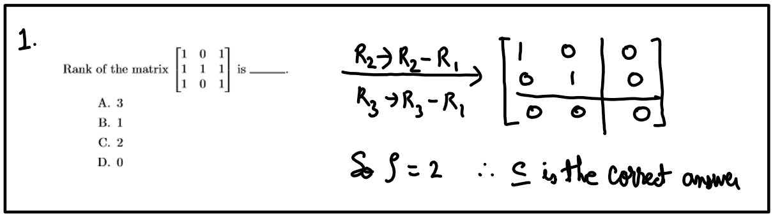

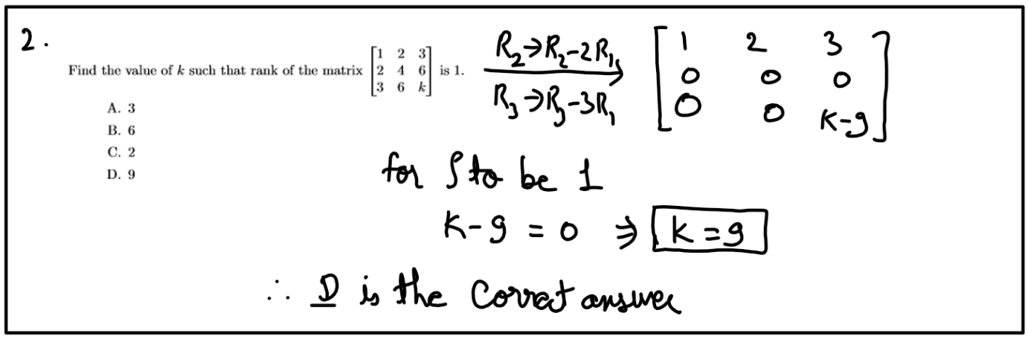

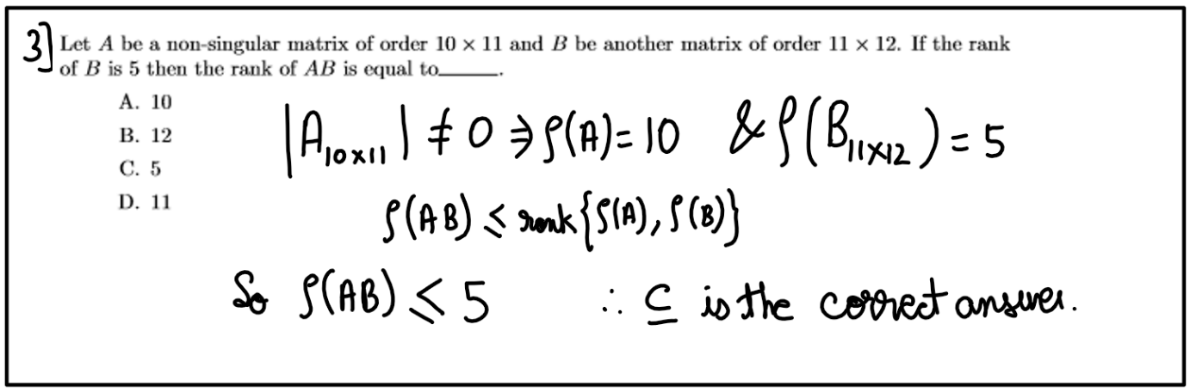

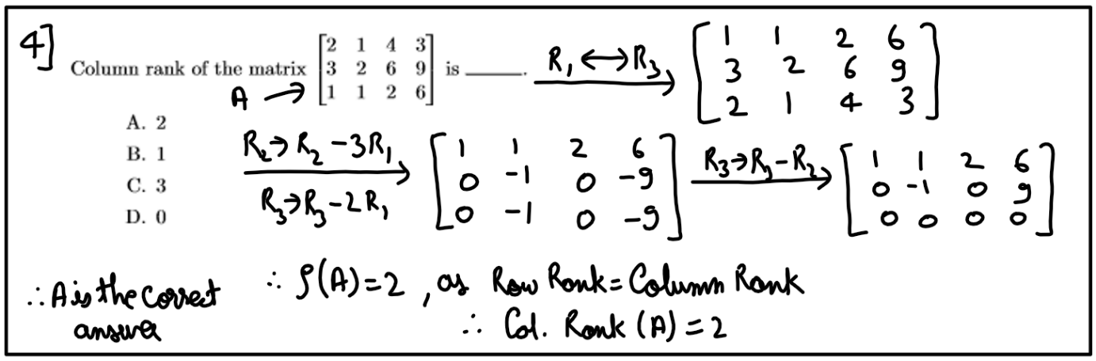

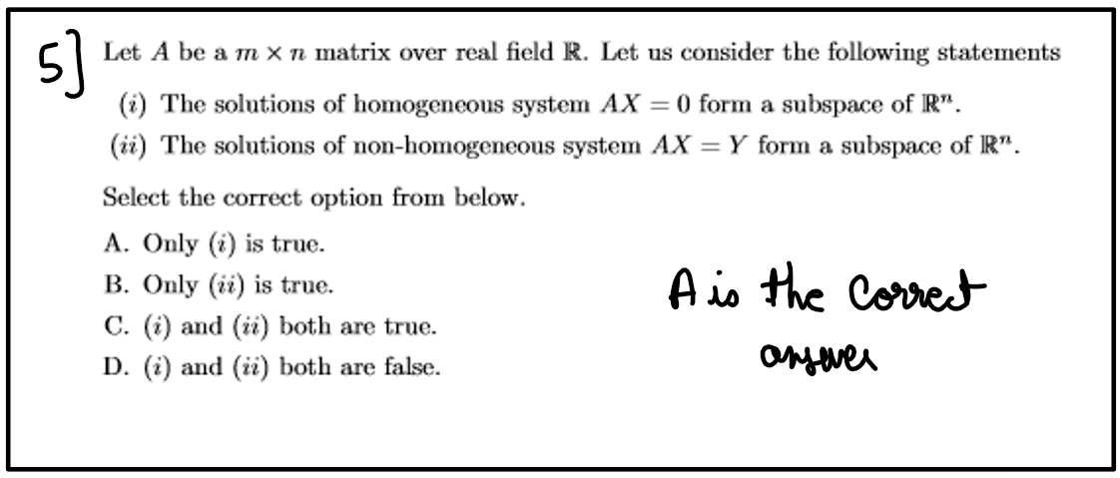

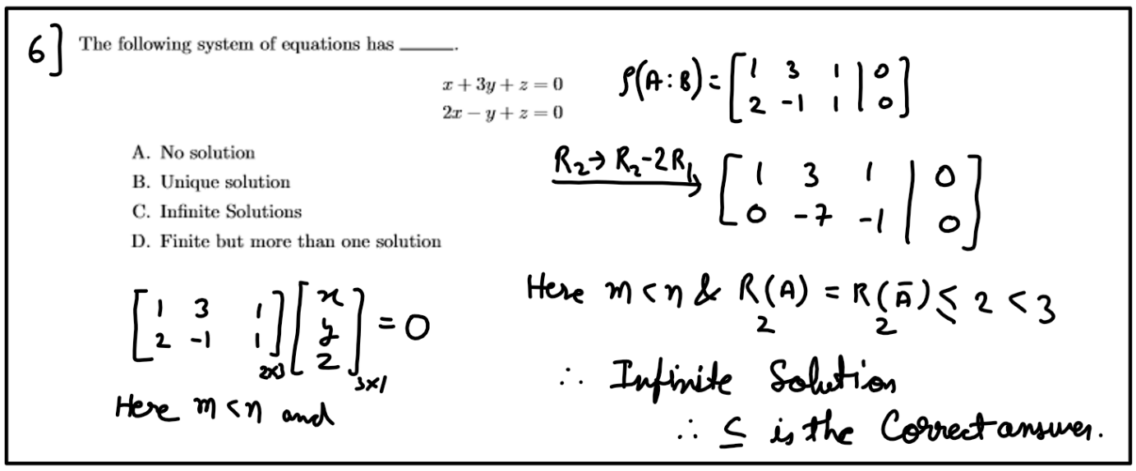

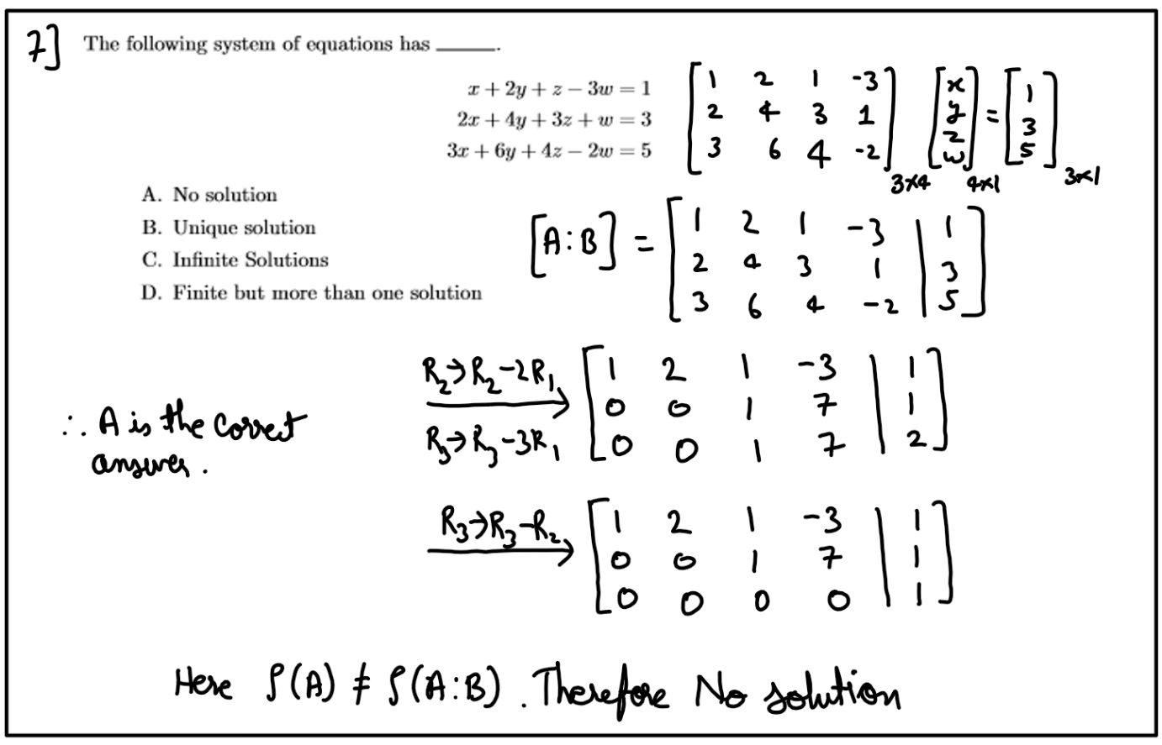

Ink Drawings
Ink Drawings
Ink Drawings
Untitled picture 
Ink Drawings
Ink Drawings
Ink Drawings
Ink Drawings
Ink Drawings
Ink Drawings
Ink Drawings
Ink Drawings
Ink Drawings
Ink Drawings
Ink Drawings
Ink Drawings
Ink Drawings
Ink Drawings
Ink Drawings
Ink Drawings
Ink Drawings
Ink Drawings
Ink Drawings
Ink Drawings
Ink Drawings
Ink Drawings
Ink Drawings
Ink Drawings
Ink Drawings
Ink Drawings
Ink Drawings
﷐𝑥=−6,𝑦=5,𝑧=−1﷯
﷐﷐1﷮2﷮3﷮1﷮3﷮6﷮2﷮6﷮13﷯﷯﷐﷐𝑥﷮𝑦﷮𝑧﷯﷯=﷐﷐1﷮3﷮5﷯﷯
Ink Drawings
Ink Drawings
Ink Drawings
Ink Drawings
Ink Drawings
Ink Drawings
Ink Drawings
Ink Drawings
Ink Drawings
Ink Drawings
Ink Drawings
Ink Drawings
Ink Drawings
Ink Drawings
Ink Drawings
Ink Drawings
Ink Drawings
Ink Drawings
Ink Drawings
Ink Drawings
Ink Drawings
Ink Drawings
Ink Drawings
Ink Drawings
Ink Drawings
Ink Drawings
Ink Drawings
Ink Drawings
Ink Drawings
Ink Drawings
Ink Drawings
Ink Drawings
Ink Drawings
Ink Drawings
Ink Drawings
Ink Drawings
Ink Drawings
Ink Drawings
Ink Drawings
Ink Drawings
Ink Drawings
Ink Drawings
Ink Drawings
Ink Drawings
Ink Drawings
Ink Drawings
Ink Drawings
Ink Drawings
Ink Drawings
Ink Drawings
Ink Drawings
Ink Drawings
Ink Drawings
Ink Drawings
Ink Drawings
Ink Drawings
Ink Drawings
Ink Drawings
Ink Drawings
Ink Drawings
Ink Drawings
Ink Drawings
Ink Drawings
Ink Drawings
Ink Drawings
Ink Drawings
Ink Drawings
Ink Drawings
Ink Drawings
Ink Drawings
Ink Drawings
Ink Drawings
Ink Drawings
Ink Drawings
Ink Drawings
Ink Drawings
Ink Drawings
Ink Drawings
Ink Drawings
Ink Drawings
Ink Drawings
Ink Drawings
Ink Drawings
Ink Drawings
Ink Drawings
Ink Drawings
Ink Drawings
Ink Drawings
Ink Drawings
Ink Drawings
Ink Drawings
Ink Drawings
Ink Drawings
Ink Drawings
Ink Drawings
Ink Drawings
Ink Drawings
Ink Drawings
Ink Drawings
Ink Drawings
Ink Drawings
Ink Drawings
Ink Drawings
Ink Drawings
Ink Drawings
Ink Drawings
Ink Drawings
Ink Drawings
Ink Drawings
Ink Drawings
Ink Drawings
Ink Drawings
Ink Drawings
Ink Drawings
Ink Drawings
Ink Drawings
Ink Drawings
Ink Drawings
Ink Drawings
Ink Drawings
Ink Drawings
Ink Drawings
Ink Drawings
Ink Drawings
Ink Drawings
Ink Drawings
Ink Drawings
Ink Drawings
Ink Drawings
Ink Drawings
Ink Drawings
Ink Drawings
Ink Drawings
Ink Drawings
Ink Drawings
Ink Drawings
Ink Drawings
Ink Drawings
Ink Drawings
Ink Drawings
Ink Drawings
Ink Drawings
Ink Drawings
Ink Drawings
Ink Drawings
Ink Drawings
Ink Drawings
Ink Drawings
Ink Drawings
Ink Drawings
Ink Drawings
Ink Drawings
Ink Drawings
Ink Drawings
Ink Drawings
Ink Drawings
Ink Drawings
Ink Drawings
Ink Drawings
Ink Drawings
Ink Drawings
Ink Drawings
Ink Drawings
Ink Drawings
Ink Drawings
Ink Drawings
Ink Drawings
Ink Drawings
Ink Drawings
Ink Drawings
Ink Drawings
Ink Drawings
Ink Drawings
Ink Drawings
Ink Drawings
Ink Drawings
Ink Drawings
Ink Drawings


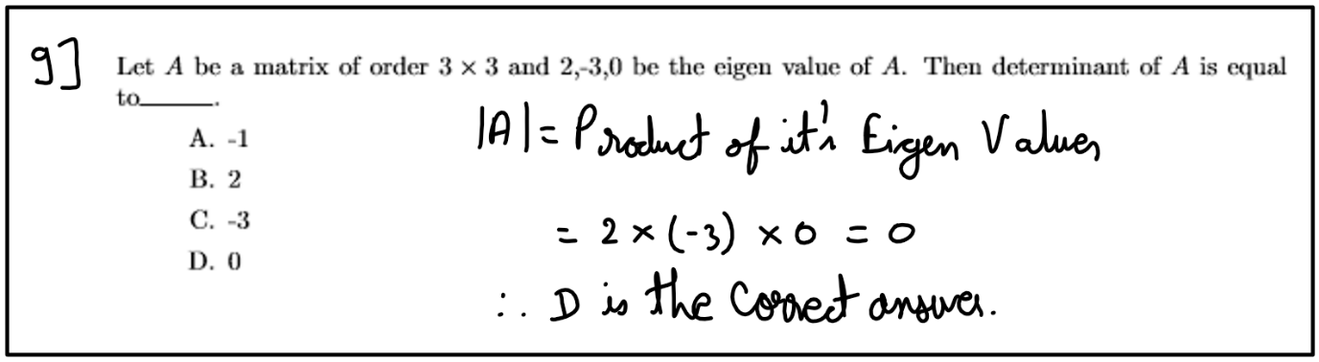

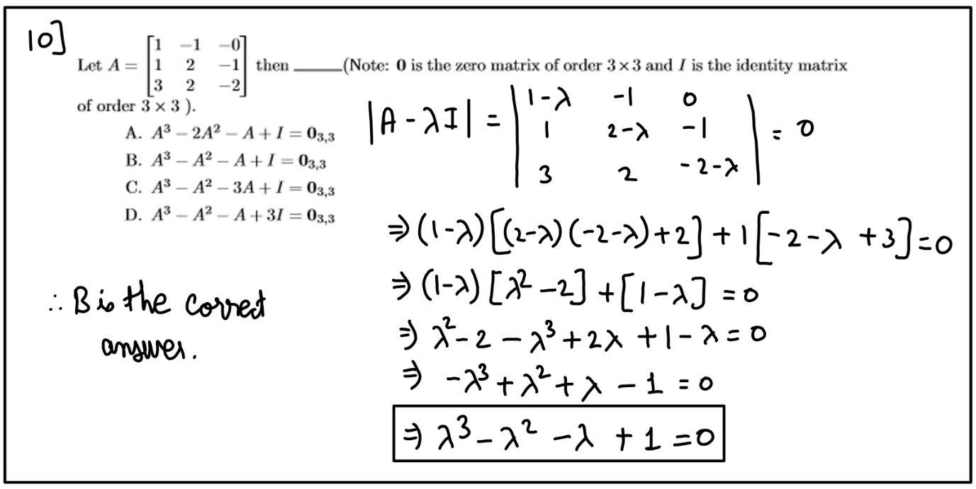

### 2023

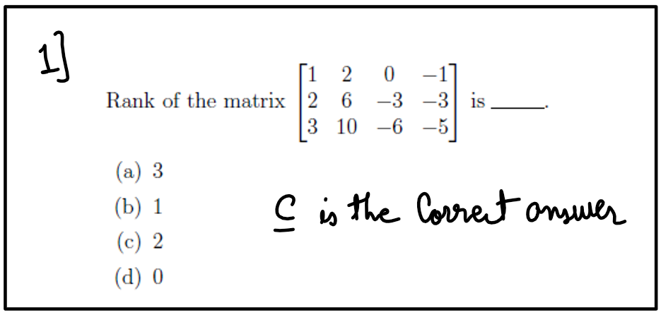

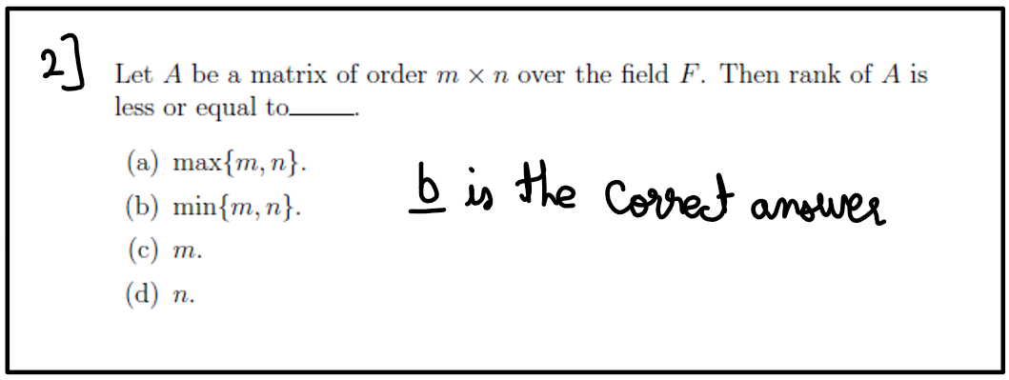

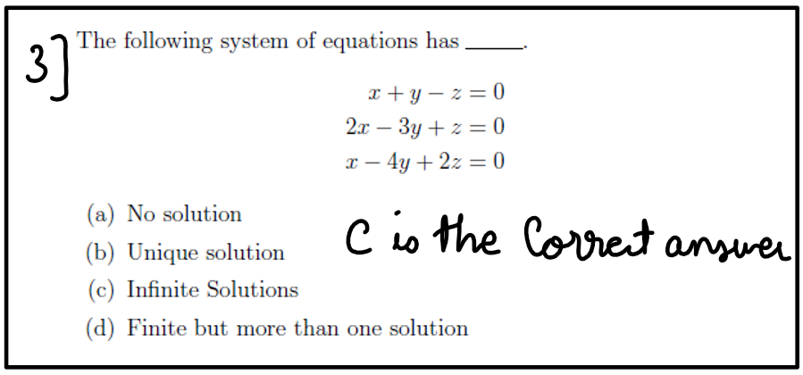

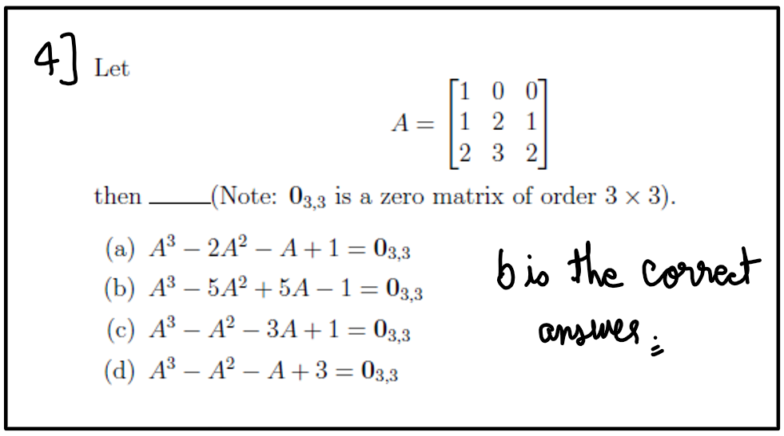

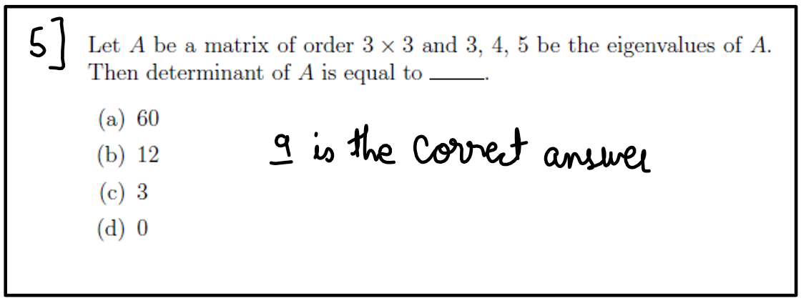

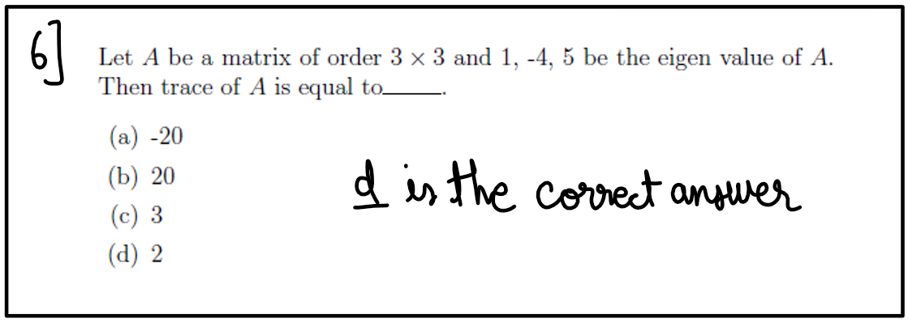

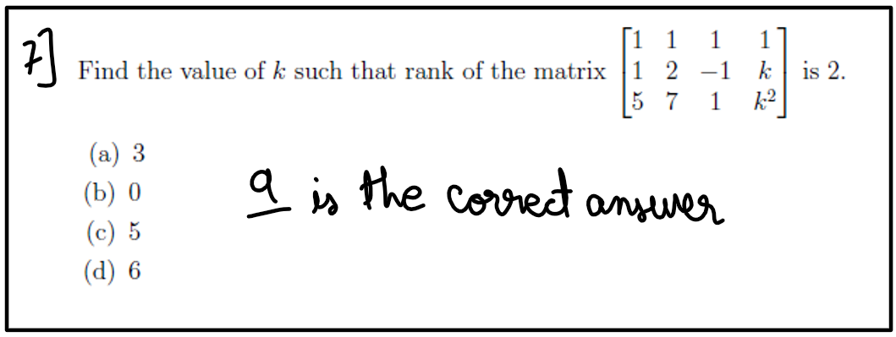

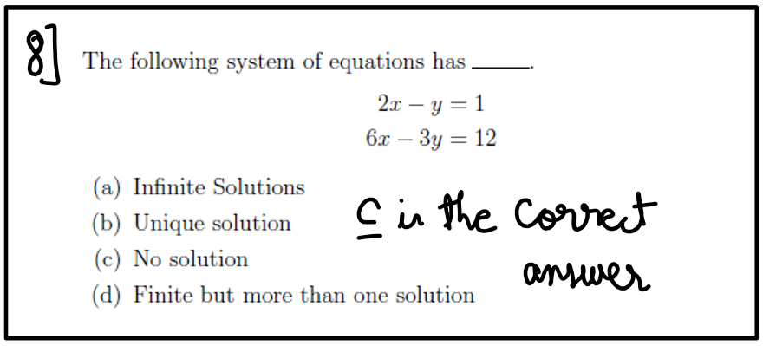

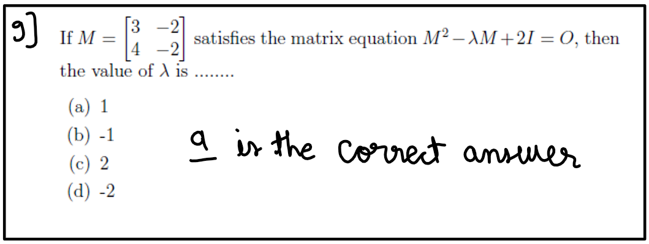

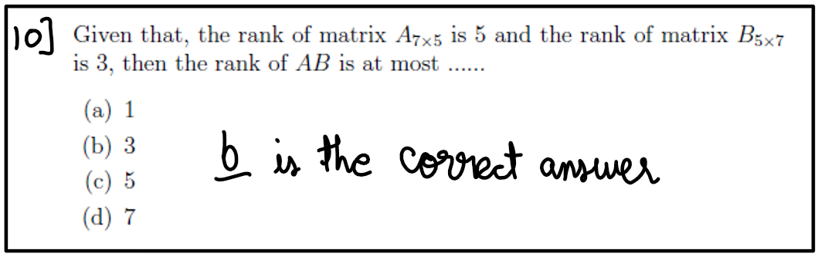

### 2024

Ink Drawings
Ink Drawings
Ink Drawings
Untitled picture 
Ink Drawings
Ink Drawings
Ink Drawings
Ink Drawings
Ink Drawings
Ink Drawings
Ink Drawings
Ink Drawings
Ink Drawings


Ink Drawings
Ink Drawings
Ink Drawings
Untitled picture 
Ink Drawings
Ink Drawings
Ink Drawings
Ink Drawings
Ink Drawings
Ink Drawings
Ink Drawings
Ink Drawings
Ink Drawings


Ink Drawings
Ink Drawings
Ink Drawings
Untitled picture 
Untitled picture 
Ink Drawings
Ink Drawings
Ink Drawings
Ink Drawings
Ink Drawings
Ink Drawings
Ink Drawings
Ink Drawings
Ink Drawings


Ink Drawings
Ink Drawings
Ink Drawings
Ink Drawings
Untitled picture 
Ink Drawings
Ink Drawings
Ink Drawings
Ink Drawings
Ink Drawings
Ink Drawings
Ink Drawings
Ink Drawings
Ink Drawings


Ink Drawings
Ink Drawings
Ink Drawings
Untitled picture 
Ink Drawings
Ink Drawings
Ink Drawings
Ink Drawings
Ink Drawings
Ink Drawings
Ink Drawings
Ink Drawings
Ink Drawings


Ink Drawings
Ink Drawings
Ink Drawings
Untitled picture 
Ink Drawings
Ink Drawings
Ink Drawings
Ink Drawings
Ink Drawings
Ink Drawings
Ink Drawings
Ink Drawings
Ink Drawings


Ink Drawings
Ink Drawings
Ink Drawings
Ink Drawings
Untitled picture 
Ink Drawings
Ink Drawings
Ink Drawings
Ink Drawings
Ink Drawings
Ink Drawings
Ink Drawings
Ink Drawings
Ink Drawings


Ink Drawings
Ink Drawings
Ink Drawings
Untitled picture 
Ink Drawings
Ink Drawings
Ink Drawings
Ink Drawings
Ink Drawings
Ink Drawings
Ink Drawings
Ink Drawings
Ink Drawings


Ink Drawings
Ink Drawings
Ink Drawings
Untitled picture 
Ink Drawings
Ink Drawings
Ink Drawings
Ink Drawings
Ink Drawings
Ink Drawings
Ink Drawings
Ink Drawings
Ink Drawings


Ink Drawings
Ink Drawings
Ink Drawings
Ink Drawings
Untitled picture 
Ink Drawings
Ink Drawings
Ink Drawings
Ink Drawings
Ink Drawings
Ink Drawings
Ink Drawings
Ink Drawings
Ink Drawings


# **Week – 08: Linear Equations**

## Lecture 36: - Eigen Vector

**Topics to be Covered**: -

* Eigen value of a non-singular matrix,
* Eigen Vector,
* Eigen Vector corresponding to unique Eigen Value, independence of eigen vectors

Ink Drawings
Theorem:-
Theorem:-
Ink Drawings
Ink Drawings
Ink Drawings
Ink Drawings
Ink Drawings
Ink Drawings
Ink Drawings
Ink Drawings
Ink Drawings
Ink Drawings
Ink Drawings
Ink Drawings
Ink Drawings
Ink Drawings
Ink Drawings
Ink Drawings
Ink Drawings
Ink Drawings
Ink Drawings
Ink Drawings
Ink Drawings
Ink Drawings
Ink Drawings
Ink Drawings
Ink Drawings
Ink Drawings
Ink Drawings
Ink Drawings
Ink Drawings
Ink Drawings
Ink Drawings
Ink Drawings
Ink Drawings
Ink Drawings
Ink Drawings
Ink Drawings
Ink Drawings
Ink Drawings
Ink Drawings
Ink Drawings
Ink Drawings
Ink Drawings
Ink Drawings
Ink Drawings
Ink Drawings
Ink Drawings
Ink Drawings
Ink Drawings
Ink Drawings
Ink Drawings
Ink Drawings


Ink Drawings
Ink Drawings
Ink Drawings
Ink Drawings
Ink Drawings
Ink Drawings
Ink Drawings
Ink Drawings
Ink Drawings
Ink Drawings
Ink Drawings
Ink Drawings
Ink Drawings
Ink Drawings
Ink Drawings
Ink Drawings
Ink Drawings
Ink Drawings
Ink Drawings
Ink Drawings
Ink Drawings
Ink Drawings
Ink Drawings
Ink Drawings
Ink Drawings
Ink Drawings
Ink Drawings
Ink Drawings
Ink Drawings
Ink Drawings
Ink Drawings
Ink Drawings
Ink Drawings
Ink Drawings
Ink Drawings
Ink Drawings
Ink Drawings
Ink Drawings
Ink Drawings
Ink Drawings
Ink Drawings
Ink Drawings
Ink Drawings
Ink Drawings
Ink Drawings
Ink Drawings
Ink Drawings
Ink Drawings
Ink Drawings
Ink Drawings
Ink Drawings
Ink Drawings
Ink Drawings
Ink Drawings
Ink Drawings
Ink Drawings
Ink Drawings
Ink Drawings
Ink Drawings
Ink Drawings
Ink Drawings
Ink Drawings
Ink Drawings
Ink Drawings
Ink Drawings
Ink Drawings
Ink Drawings
Ink Drawings
Ink Drawings
Ink Drawings
Ink Drawings
Ink Drawings
Ink Drawings
Ink Drawings
Ink Drawings
Ink Drawings
Ink Drawings
Ink Drawings
Ink Drawings
Ink Drawings
Ink Drawings
Ink Drawings
Ink Drawings
Ink Drawings
Ink Drawings
Ink Drawings
Ink Drawings
Ink Drawings
Ink Drawings
Ink Drawings
Ink Drawings
Ink Drawings
Ink Drawings
Ink Drawings
Ink Drawings
Ink Drawings
Ink Drawings
Ink Drawings
Ink Drawings
Ink Drawings
Ink Drawings
Ink Drawings
Ink Drawings
Ink Drawings
Ink Drawings
Ink Drawings
Ink Drawings
Ink Drawings
Ink Drawings
Ink Drawings
Ink Drawings
Ink Drawings
Ink Drawings
Ink Drawings
Ink Drawings
Ink Drawings
Ink Drawings
Ink Drawings
Ink Drawings
Ink Drawings
Ink Drawings
Ink Drawings
Ink Drawings
Ink Drawings
Ink Drawings
Ink Drawings
Ink Drawings
Ink Drawings
Ink Drawings
Ink Drawings
Ink Drawings
Ink Drawings
Ink Drawings
Ink Drawings
Ink Drawings
Ink Drawings
Ink Drawings
Ink Drawings
Ink Drawings
Ink Drawings
Ink Drawings
Ink Drawings
Ink Drawings
Ink Drawings
Ink Drawings
Ink Drawings
Ink Drawings
Ink Drawings
Ink Drawings
Ink Drawings
Ink Drawings
Ink Drawings
Ink Drawings
Ink Drawings
Ink Drawings
Ink Drawings
Ink Drawings
Ink Drawings
Ink Drawings
Ink Drawings
Ink Drawings
Ink Drawings
Ink Drawings
Ink Drawings
Ink Drawings
Ink Drawings
Ink Drawings
Ink Drawings
Ink Drawings
Ink Drawings
Ink Drawings
Ink Drawings
Ink Drawings
Ink Drawings
Ink Drawings
Ink Drawings
Ink Drawings
Ink Drawings
Ink Drawings
Ink Drawings
Ink Drawings
Ink Drawings
Ink Drawings
Ink Drawings
Ink Drawings
Ink Drawings
Ink Drawings
Ink Drawings
Ink Drawings
Ink Drawings
Ink Drawings
Ink Drawings
Ink Drawings
Ink Drawings
Ink Drawings
Ink Drawings
Ink Drawings
Ink Drawings
Ink Drawings
Ink Drawings
Ink Drawings
Ink Drawings
Ink Drawings
Ink Drawings
Ink Drawings
Ink Drawings
Ink Drawings
Ink Drawings
Ink Drawings
Ink Drawings
Ink Drawings
Ink Drawings
Ink Drawings
Ink Drawings
Ink Drawings
Ink Drawings
Ink Drawings
Ink Drawings
Ink Drawings
Ink Drawings
Ink Drawings
Ink Drawings
Ink Drawings
Ink Drawings
Ink Drawings
Ink Drawings
Ink Drawings
Ink Drawings
Ink Drawings
Ink Drawings
Ink Drawings
Ink Drawings
Ink Drawings
Ink Drawings
Ink Drawings
Ink Drawings
Ink Drawings
Ink Drawings
Ink Drawings
Ink Drawings
Ink Drawings
Ink Drawings
Ink Drawings
Ink Drawings
Ink Drawings
Ink Drawings
Ink Drawings
Ink Drawings
Ink Drawings
Ink Drawings
Ink Drawings
Ink Drawings
Ink Drawings
Ink Drawings
Ink Drawings
Ink Drawings
Ink Drawings
Ink Drawings
Ink Drawings


Ink Drawings
Theorem:-
Theorem:-
Ink Drawings
Ink Drawings
Ink Drawings
Ink Drawings
Ink Drawings
Ink Drawings
Ink Drawings
Ink Drawings
Ink Drawings
Ink Drawings
Ink Drawings
Ink Drawings
Ink Drawings
Ink Drawings
Ink Drawings
Ink Drawings
Ink Drawings
Ink Drawings
Ink Drawings
Ink Drawings
Ink Drawings
Ink Drawings
Ink Drawings
Ink Drawings
Ink Drawings
Ink Drawings
Ink Drawings
Ink Drawings
Ink Drawings
Ink Drawings
Ink Drawings
Ink Drawings
Ink Drawings
Ink Drawings
Ink Drawings
Ink Drawings
Ink Drawings
Ink Drawings
Ink Drawings
Ink Drawings
Ink Drawings
Ink Drawings
Ink Drawings
Ink Drawings
Ink Drawings
Ink Drawings
Ink Drawings
Ink Drawings
Ink Drawings
Ink Drawings
Ink Drawings
Ink Drawings


Ink Drawings
Ink Drawings
Ink Drawings
Ink Drawings
Ink Drawings
Ink Drawings
Ink Drawings
Ink Drawings
Ink Drawings
Ink Drawings
Ink Drawings
Ink Drawings
Ink Drawings
Ink Drawings
Ink Drawings
Ink Drawings
Ink Drawings
Ink Drawings
Ink Drawings
Ink Drawings
Ink Drawings
Ink Drawings
Ink Drawings
Ink Drawings
Ink Drawings
Ink Drawings
Ink Drawings
Ink Drawings
Ink Drawings
Ink Drawings
Ink Drawings
Ink Drawings
Ink Drawings
Ink Drawings
Ink Drawings
Ink Drawings
Ink Drawings
Ink Drawings
Ink Drawings
Ink Drawings
Ink Drawings
Ink Drawings
Ink Drawings
Ink Drawings
Ink Drawings
Ink Drawings
Ink Drawings
Ink Drawings
Ink Drawings
Ink Drawings
Ink Drawings
Ink Drawings
Ink Drawings
Ink Drawings
Ink Drawings
Ink Drawings
Ink Drawings
Ink Drawings
Ink Drawings
Ink Drawings
Ink Drawings
Ink Drawings
Ink Drawings
Ink Drawings
Ink Drawings
Ink Drawings
Ink Drawings
Ink Drawings
Ink Drawings
Ink Drawings
Ink Drawings
Ink Drawings
Ink Drawings
Ink Drawings
Ink Drawings
Ink Drawings
Ink Drawings
Ink Drawings
Ink Drawings
Ink Drawings
Ink Drawings
Ink Drawings
Ink Drawings
Ink Drawings
Ink Drawings
Ink Drawings
Ink Drawings
Ink Drawings
Ink Drawings
Ink Drawings
Ink Drawings
Ink Drawings
Ink Drawings
Ink Drawings
Ink Drawings
Ink Drawings
Ink Drawings
Ink Drawings
Ink Drawings
Ink Drawings
Ink Drawings
Ink Drawings
Ink Drawings
Ink Drawings
Ink Drawings
Ink Drawings
Ink Drawings
Ink Drawings
Ink Drawings
Ink Drawings
Ink Drawings
Ink Drawings
Ink Drawings
Ink Drawings
Ink Drawings
Ink Drawings
Ink Drawings
Ink Drawings
Ink Drawings
Ink Drawings
Ink Drawings
Ink Drawings
Ink Drawings
Ink Drawings
Ink Drawings
Ink Drawings
Ink Drawings
Ink Drawings
Ink Drawings
Ink Drawings
Ink Drawings
Ink Drawings
Ink Drawings
Ink Drawings
Ink Drawings
Ink Drawings
Ink Drawings
Ink Drawings
Ink Drawings
Ink Drawings
Ink Drawings
Ink Drawings
Ink Drawings
Ink Drawings
Ink Drawings
Ink Drawings
Ink Drawings
Ink Drawings
Ink Drawings
Ink Drawings
Ink Drawings
Ink Drawings
Ink Drawings
Ink Drawings
Ink Drawings
Ink Drawings
Ink Drawings
Ink Drawings
Ink Drawings
Ink Drawings
Ink Drawings
Ink Drawings
Ink Drawings
Ink Drawings
Ink Drawings
Ink Drawings
Ink Drawings
Ink Drawings
Ink Drawings
Ink Drawings
Ink Drawings
Ink Drawings
Ink Drawings
Ink Drawings
Ink Drawings
Ink Drawings
Ink Drawings
Ink Drawings
Ink Drawings
Ink Drawings
Ink Drawings
Ink Drawings
Ink Drawings
Ink Drawings
Ink Drawings
Ink Drawings
Ink Drawings
Ink Drawings
Ink Drawings
Ink Drawings
Ink Drawings
Ink Drawings
Ink Drawings
Ink Drawings
Ink Drawings
Ink Drawings
Ink Drawings
Ink Drawings
Ink Drawings
Ink Drawings
Ink Drawings
Ink Drawings
Ink Drawings
Ink Drawings
Ink Drawings
Ink Drawings
Ink Drawings
Ink Drawings
Ink Drawings
Ink Drawings
Ink Drawings
Ink Drawings
Ink Drawings
Ink Drawings
Ink Drawings
Ink Drawings
Ink Drawings
Ink Drawings
Ink Drawings
Ink Drawings
Ink Drawings
Ink Drawings
Ink Drawings
Ink Drawings
Ink Drawings
Ink Drawings
Ink Drawings
Ink Drawings
Ink Drawings
Ink Drawings
Ink Drawings
Ink Drawings
Ink Drawings
Ink Drawings
Ink Drawings
Ink Drawings
Ink Drawings
Ink Drawings
Ink Drawings
Ink Drawings
Ink Drawings
Ink Drawings
Ink Drawings
Ink Drawings
Ink Drawings
Ink Drawings
Ink Drawings
Ink Drawings
Ink Drawings
Ink Drawings
Ink Drawings
Ink Drawings
Ink Drawings
Ink Drawings
Ink Drawings
Ink Drawings
Ink Drawings
Ink Drawings
Ink Drawings


# **Test Papers of 2025**

## Week – 01:

To be Continued….

## Week – 07:

To be Continued….

# **Important Links**

Current: - <https://onlinecourses.nptel.ac.in/noc25_ma78/preview>

2019: - <https://onlinecourses.nptel.ac.in/noc19_ma23/preview>

2023: - <https://onlinecourses.nptel.ac.in/noc23_ma87/preview>

2024: - <https://onlinecourses.nptel.ac.in/noc24_ma58/preview>